Submission to the NDIS Support for Decision Making consultation
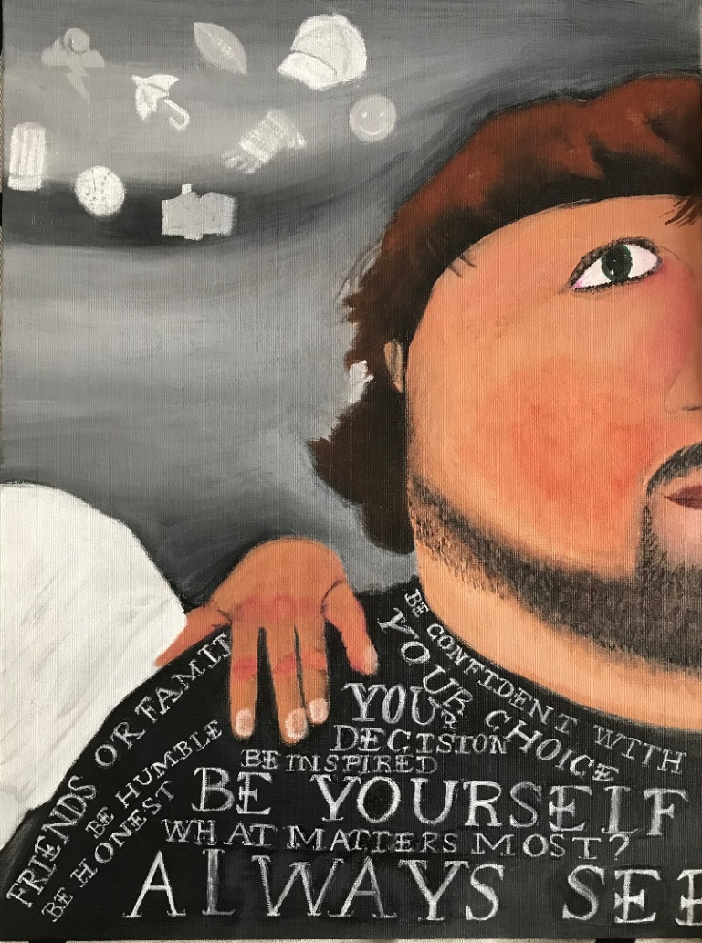
Contents

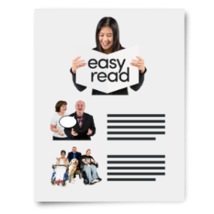
About this document Page 3

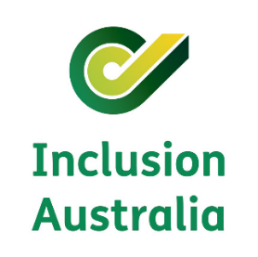
About Inclusion Australia Page 5

About our report Page 7

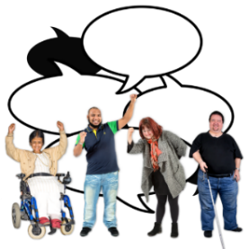
Rights Page 9

Principles Page 11
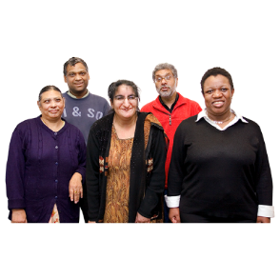

Cultural diversity Page 13

Complex communication needs Page 15

Decision making framework Page 18

Safeguards Page 20

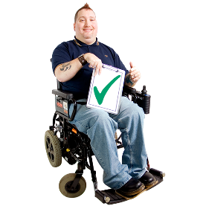
Accessibility and Co-design Page 22

Cover artwork: My Path, My Decisions by George Williams.

About this document

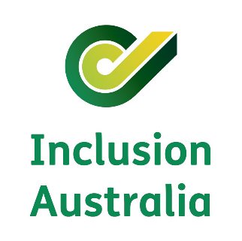
This document was written by Inclusion Australia.
When you see the word ‘we’ it means Inclusion Australia.

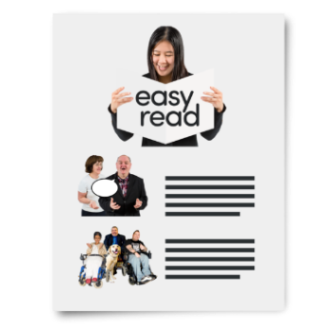
We wrote this document in an easy to read way. We use pictures to help explain some ideas.

Difficult words are written in bold.
We explain what these words mean.

This is an Easy Read version of our original report.

This means it only includes the most important ideas.

You can find the original report on our website
www.inclusionaustralia.org.au

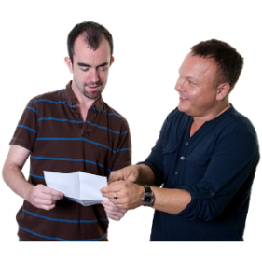
You can ask a family member, friend or support person to help you read this document.

About Inclusion Australia

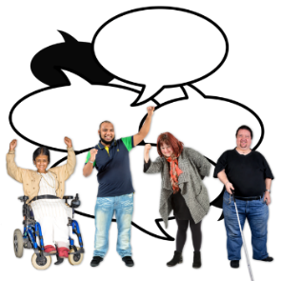
Inclusion Australia is a national organisation that speaks up for the rights and interests of people with an intellectual disability and their families.

We run projects and activities for people with an intellectual disability and their supporters.

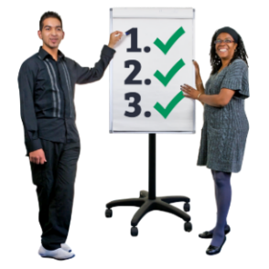
We are the main group that gives advice and feedback to the Government and other organisations to help make things better for people with an intellectual disability.

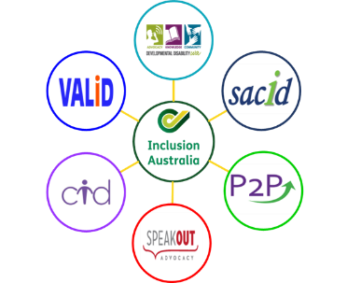
We have member organisations in
- New South Wales
- Victoria
- Queensland
- South Australia
- Tasmania
- Western Australia.

To learn more about Inclusion Australia visit our website
www.inclusionaustralia.org.au

About our Report

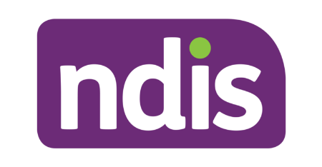
In June 2021 the National Disability Insurance Agency (NDIA) made a plan for doing supported decision making in the National Disability Insurance Scheme (NDIS).

We call this plan the ‘SDM Policy’ for short.

Supported decision making means making your own decisions with support from people you trust.

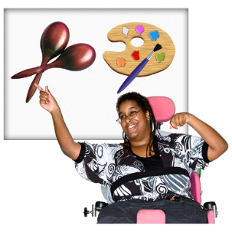
Supported decision making is important because it helps people with an intellectual disability

- have a say in how they live their lives

- to be more independent

- become confident at making their own choices
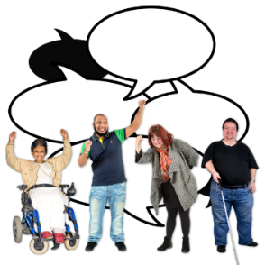
The NDIA asked people with disability, their families, supporters, and advocates to share what they thought about the SDM Policy.

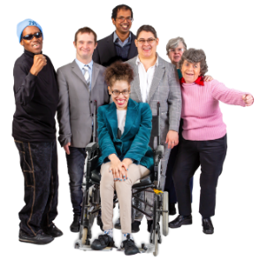
To help us write our report we listened to people with intellectual disability, their families and supporters from around Australia.

We also spoke with our member organisations and other disability organisations across Australia.

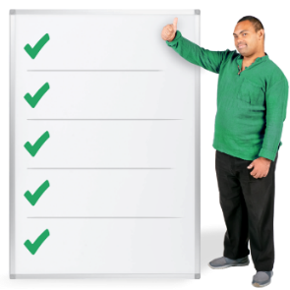
We told the NDIA we are happy they understand that supported decision making is important, but that the SDM Policy could be better.

We gave the NDIA some ideas on how to change the SDM Policy to make it better.
Rights

People with an intellectual disability have the right to make their own decisions just like everyone else.

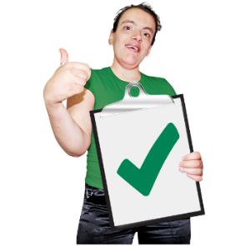
We think the NDIA understands it is important for people with disability to be able to make their own decisions.

People with an intellectual disability said it was good to see the NDIA wants to have support for decision making in people’s NDIS plans.

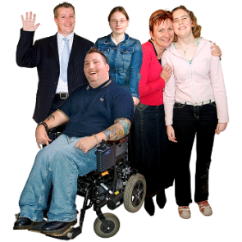
They also liked that decision supporters will get information about how to do support decision making.

But some people said their NDIS supports were not flexible and it was hard to get support when they changed their mind.

We think the SDM Policy needs to make sure NDIS participants have the support they need to change their mind.

Principles

The SDM Policy talks about 4 key principles for supported decision making.

A principle is an idea or rule you should follow.

We think the SDM Policy principles are missing some important information about supported decision making.

Some people we spoke to were confused that the NDIA wrote their own principles instead of using the National Decision Making Principles.

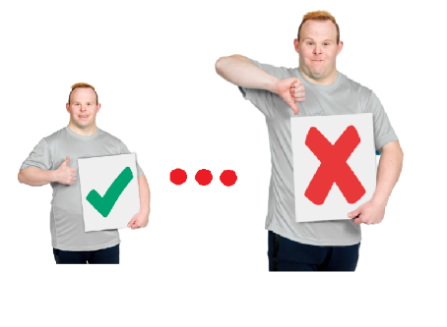
The National Decision Making Principles were written by the Australian Law Reform Commission and cover all the important points of decision making.

The NDIA’s principles do not.
We think the NDIA should use the National Decision Making Principles in their SDM Policy instead.

Cultural diversity

Some people with disability are from culturally diverse backgrounds.

Being culturally diverse means you belong to a different culture, country or religion.

For example
- you are Aboriginal or Torres Strait Islander

- you speak a language other than English at home

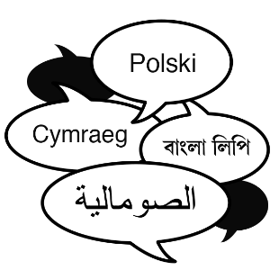
Cultural diversity is important because it means everyone feels included and can understand the information they are given.

The SDM Policy does not say much about people with disability who are culturally diverse.

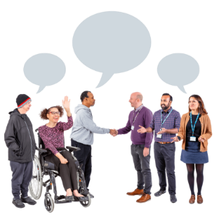
We think the NDIA needs to learn more about cultural diversity.

They can do this by talking to culturally diverse people with disability and their families to make sure the SDM Policy is inclusive for everybody.

Complex communication needs

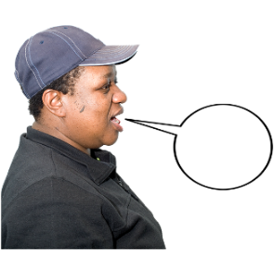
Some people with disability can say what they want and need by speaking.

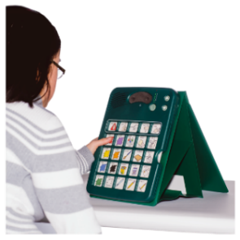
And some might use a communication aid, like an AAC device or a PODD book.

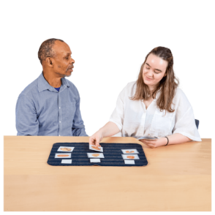
But some people with disability need support to say what they want and need.

This is called having complex communication needs.

The SDM Policy does not say much about people with complex communication needs.

We are worried the NDIA thinks people with complex communication needs cannot make their own decisions.

But everyone can make their own decisions with the right support.

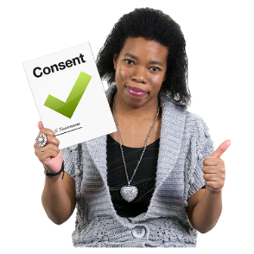
The SDM Policy says that people with disability can give consent by writing or speaking.

Giving consent means you agree with something.

But there are lots of other ways people with disability can give consent.
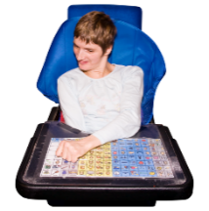
Things like nodding, making sounds, or using a communication device.

We think the NDIA needs to change the SDM Policy so it is clear that people with complex communication needs can give consent in their own way.

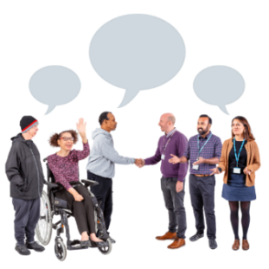
We think the NDIA should talk to people with complex communication needs and their supporters to find out how they can be better included in the SDM Policy.

Decision making framework

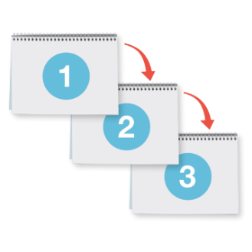
The SDM Policy talks about a decision making capability framework.

We call it ‘the Framework’ for short.

The Framework explains a way to do supported decision making.

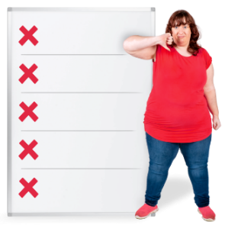
We think there are some problems with the Framework.

Some people said the Framework is not useful because there are no examples of how people with disability can use it to make big and complicated decisions like
- buying a house
- having a baby

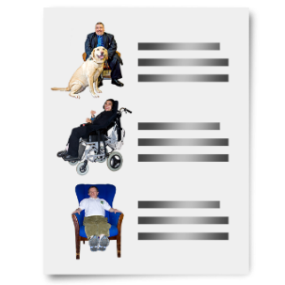
We think the Framework needs to include real life examples of how people with an intellectual disability and their supporters can use it to make big and complicated decisions.

The Framework talks about supporting people with disability to ‘make good choices’.

But people with disability have the right to make choices that other people may not like or agree with just like everyone else.

People with disability also have the right to make risky decisions and learn from their mistakes.

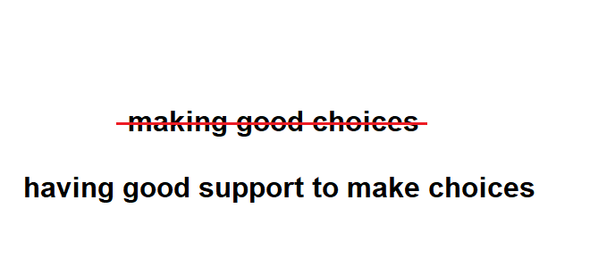
We think the Framework should not use the words 'make good choices'.

We think it should say 'have good support to make choices' instead.
Safeguards

We were glad to see the NDIA talk about safeguards in the SDM Policy.

Safeguards are rules that protect someone from being treated badly.

We think the NDIA needs to give more information about safeguards in the SDM Policy.

It’s important that people with disability can ask for what they want and need in their NDIS Plan and that they are listened to and respected.

One of the safeguards in the SDM Policy says that service providers cannot force their NDIS clients to make decisions that they don’t want or agree with.

We think this is a good safeguard.

We think there should also be a safeguard to protect NDIS clients from being forced to make decisions by
- their decision supporters
- the NDIA

We think the NDIA needs to make sure that NDIS Planners and Local Area Coordinators (LACs) are trained properly about supported decision making.

This training will help them better support people with disability to make their own decisions about their NDIS Plan.

Accessibility and Co-design

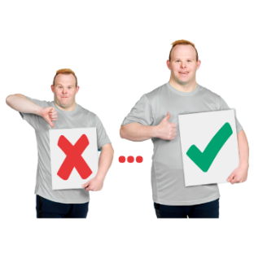
We are glad the NDIA talked with people with disability, their supporters, advocates and disability organisations when making the SDM Policy.

But we think the NDIA can do more to make the SDM Policy better.

We think the NDIA should co-design the Framework.

Co-design means working with and listening to
- people with disability
- their supporters
- advocates
- disability organisations
to make sure the SDM Policy is what people really want and need.

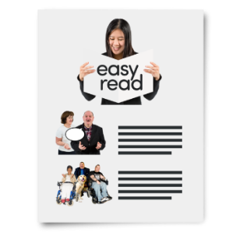
We are glad the NDIA made an Easy Read version of the SDM Policy.

Easy Read documents are good because it means everyone gets the chance to read and understand what is happening.

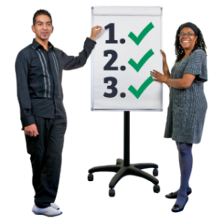
We told the NDIA some ways to make sure their Easy Read documents are accessible for everyone.

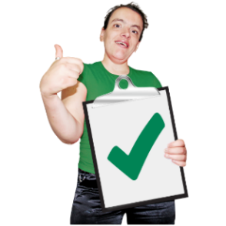

We think the NDIA should keep making Easy Read documents.

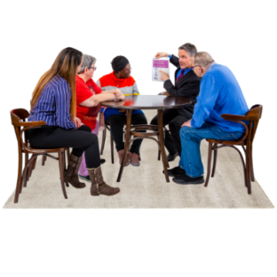
We think the NDIA should work with people with disability to make sure their Easy Read documents are inclusive for everyone.

