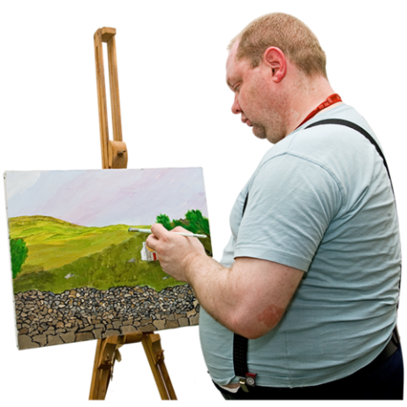

Make Decisions Real Art Competition

About Make Decisions Real
Inclusion Australia is running a project called Make Decisions Real.
We are making workshops and resources for people with intellectual disability and their supporters to learn about supported decision making.

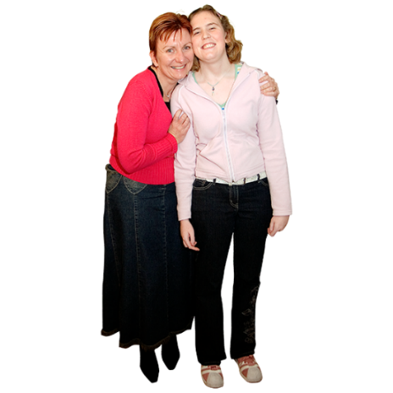
Supported decision making is about helping people with intellectual disability make their own decisions.
The workshops are made and presented by people with intellectual disability.

The workshops will happen in different cities around Australia in 2022.

About the art competition
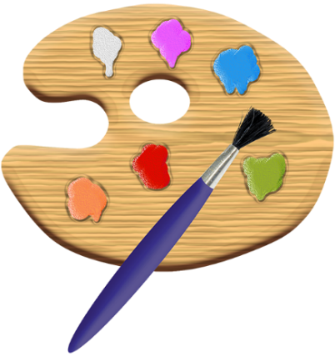
We are looking for people with intellectual disability to make artwork and enter it in our competition.

The theme for the artwork is I make my own decisions.

The winners will be chosen by the project Peer Workers.

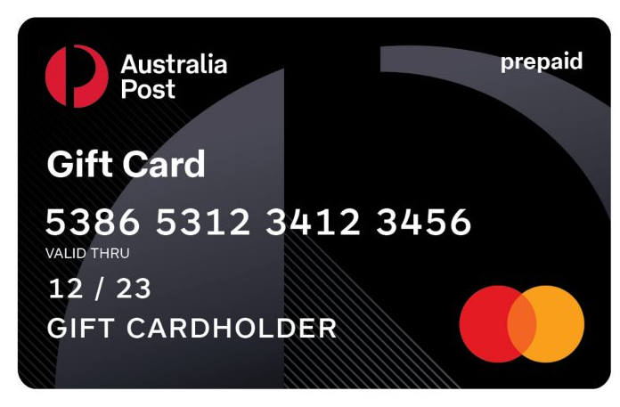
The winners will get a $500 gift card and their art will be used in the Make Decisions Real workshops and resources.

Your artwork could be a painting, a drawing, a picture of a sculpture or digital media
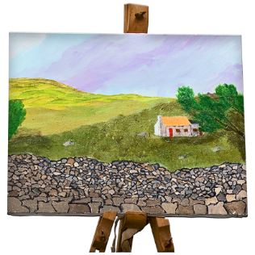
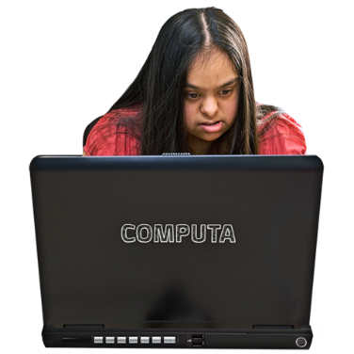
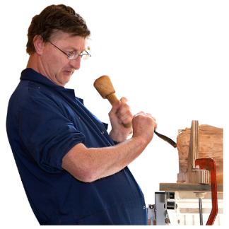
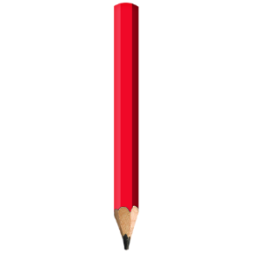

How to enter the competition
To enter the competition you must:
☐ Be person with an intellectual disability
☐ Be over 18 years of age
☐ Enter 1 artwork only
☐ Create an artwork based on the theme I make my own decisions
☐ Agree that if you are a winner, you give Inclusion Australia your permission to use your artwork in the Make Decisions Real workshops and resources
☐ Send your application form and a photocopy of your artwork to brooke.canham@inclusionaustralia.org.au by Friday 30 July 2021

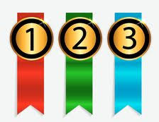
Prizes
3 winning artworks will be chosen by the Make Decisions Real peer workers.

The winners will get a $500 gift card and their artwork will be used in the Make Decisions Real workshops and resources.

Anything else?
If you have any questions about the Art Competition you can email
Riley Buchanan
riley.buchanan@inclusionaustralia.org.au

Application Form
Your name:

Address:

Telephone:

Email:

Do you have another support person you want us to contact?
Yes ☐ No ☐

Artwork title:

Do you want to tell us more about your artwork?

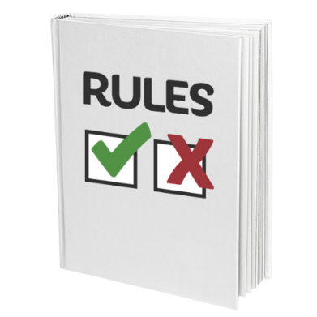

Conditions of Entry
☐ I am over 18 years of age
☐ I am a person with intellectual disability
☐ If I win the Make Decisions Real art competition I give permission for Inclusion Australia to use my artwork in the Make Decisions Real workshops and resources

Signed:

Date:

