Easy Read Feedback and Complaint Form
You have the right to give feedback and make a complaint about your service.
Feedback is when you say what you think about the service.
A complaint is when you speak up about something that is wrong.
You can use this form to give feedback or make a complaint.
You can ask someone you can trust to help you with this form.
Write as much as you can.
You do not have to answer every question.

Please write
Your name
Click or tap here to enter text.
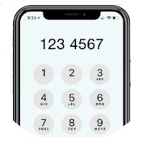 | Your phone number  Click or tap here to enter text.  Or your email  Click or tap here to enter text.
Today’s date
Click or tap here to enter text.

Please tick one of the boxes
☐ I want to give feedback.
☐ I want to make a complaint.

You can write your feedback or complaint here

What happened?
Click or tap here to enter text.

Who was there?
Click or tap here to enter text.

What date and time did it happen?
Click or tap here to enter text.

Where did it happen?
Click or tap here to enter text.

Did someone help you with this form?
Please tell us
Their name
Click or tap here to enter text.

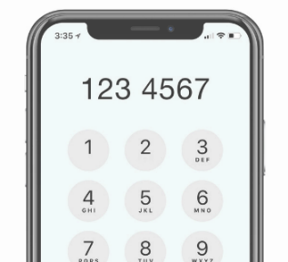 | Their phone number  Click or tap here to enter text.
 | You can give this form to any staff member at [Disability Service Provider Name]. [Change if service provider has different arrangements].
 | We will take your feedback or complaint seriously.

If you need more support you can get support from an advocate.
An advocate helps people speak up.

You can get support from an advocate at [Name of local advocacy service].
You can call [pdsadsadsahone number of local advocacy service]
Email [email address of local advocacy service]
If your feedback or complaint is not listened to or you are not happy with the results, you can contact the NDIS Quality and Safeguards Commission:
1800 035 544
or
https://www.ndiscommission.gov.au/
about/complaints

