DES Reform Submission

  - Plain English Summary

Introduction
Inclusion Australia wants big changes to the current Disability Employment Services (DES)
because they are failing people with an intellectual disability and their families. Currently,
only 3.1% of those using DES are people with an intellectual disability.
People with an intellectual disability have the right to work, and to be paid fairly for that work.
Most people with an intellectual disability do not have access to paid work in open and self-
employment. This means that most people with an intellectual disability live in poverty,
with no opportunity to have the same lives as non-disabled people, and other people with
disability.
People with an intellectual disability have to find their way through lots of different systems when they are looking for support to get and keep a job. These systems are Disability Employment Services (DES), the National Disability Insurance Scheme (NDIS), the Disability Support Pension (DSP), Centrelink and school. We think all this needs to be much easier.
There has been lots of research into different ways to support people with an intellectual disability at work. That research has found there are ways that are good and we’ve used that research in our submission.
Inclusion Australia’s Our Voice Committee, who are all people with an intellectual disability, say that “People with disabilities have the right to work in the open market like anyone else, and get the training and support they need; this means no more sheltered workshops.”

About this submission
This is a plain English summary of the submission we sent to the Federal Government about Disability Employment Services. It doesn’t include all the information that was in the long submission. We talked to lots of different people with an intellectual disability and their families, who shared their experiences and expertise.
The submission is in two parts – the first part is some general issues, and the second part looks at different times in a person with an intellectual disability’s life.
We also used lots of research, including a big document called Fostering employment for people with an intellectual disability: the evidence to date by Professor Erin Wilson and Robert Campain. This is called the Swinburne Research in this submission.
Inclusion Australia and our members also have some projects about employment which we have talked about in this submission.
We thank everyone for putting in lots of work and effort to help us with this submission.

Centre of Excellence and specialist DES providers
Inclusion Australia wants a Centre of Excellence in open and self-employment of people with an intellectual disability to be set up. We also want to see specialist Disability Employment Services organisations in every state and territory, who know about what works to support people with an intellectual disability at work.
Lots of DES don’t know about people with an intellectual disability, or about what works to get a job and keep people at work.
People with an intellectual disability and their families find it hard to get accessible, independent information about employment, as well as the NDIS and Centrelink.
A Centre of Excellence, as well as specialist DES will know what kinds of programs and supports work the best for people with an intellectual disability and their families.
They will make information accessible and available to people with an intellectual disability and their families so they can find their way through complicated systems, like the NDIS and Centrelink.
The Centre of Excellence will use the evidence to make guides about open and self-employment for:
- People with an intellectual disability and their families
- Schools
- General Disability Employment Services
- Employers
The Centre will also get everyone together to share information and expertise about what works. They will employ people with an intellectual disability who know about employment, and be a good place to work with the right support.
Specialist Disability Employment Services will:
- Train other employment services in what works for people with an intellectual disability
- Support people with an intellectual disability into open and self-employment
- Work with the Centre of Excellence to promote what works to employers.

What we recommend
Set up a Centre of Excellence and some specialist Disability Employment Services that employ people with an intellectual disability and know lots about the kinds of support they need.

Why is open and self-employment important?

We know that people with an intellectual disability can and do work in open and self-employment. Inclusion Australia’s Our Voice committee, who are all people with an intellectual disability, say clearly that they do not want to work in sheltered workshops, also known as Australian Disability Enterprises (ADEs).
Barriers to work
There are lots of obstacles in the way of people with an intellectual disability who want to get and keep a job. These obstacles can be the low expectations that other people have, and not having the same kinds of choices.
Big systems, like the NDIS and DES, can also be an obstacle to working in a regular job or having a business. We want to change that.
Self-employment
Self-employment means starting a business, and using different kinds of supports to do that, like circles of support.
People with an intellectual disability can find self-employment works well for them as it can be flexible and give people more choice. The current DES and NDIS systems don’t support self-employment very well, and need to do better. There needs to be lots more information about self-employment for people with an intellectual disability and their families.
Systems complexity and cooperation
People with an intellectual disability and their families have to navigate multiple systems when accessing supports for open and self-employment. These include:
- Disability Employment Services (DES)
- Centrelink and the Disability Support Pension (DSP)
- National Disability Insurance Scheme employment supports
- The education system
- Housing
- Health and Medicare
There are also lots of different plans being made by the Federal Government that don’t include people with an intellectual disability.
We want to see all of these systems and plans working better together so that people with an intellectual disability and their families don’t have to do so much work to find their way. We want the Federal Government to get everyone together and making things easier to understand.
What we recommend
Get all the different people who work in the different systems together and ask them to make them both simpler to use and work together better.

Disability Employment Services
We think there are lots of things that need to change about the current Disability Employment Services system to make it work better for people with an intellectual disability and their families. At the moment, nearly all people with an intellectual disability don’t get access to DES supports.
The people that work at DES providers need to understand people with an intellectual disability better, and know how to support them at work. They also need more time to spend with people with an intellectual disability and to know about what the research says is the best approach.
We don’t think that DES providers should be in competition with each other, but instead should work together to support people with an intellectual disability.
It can be really hard to find out which DES providers are doing a good job at supporting people with an intellectual disability at work. We want that to be really clear and easy to understand.
There’s a new employment service coming for everyone looking for a job, called the New Employment Services Model. This new way will mean most people with disability will have to use digital tools to access support, and we are worried about what that means for people with an intellectual disability. We think there needs to be more information and resources to help people with an intellectual disability figure out this new system.
What we recommend
- Get all the Disability Employment Services to work together.
- Have more information about the new system of employment support.

Centrelink
Many people with an intellectual disability rely on the Disability Support Pension (DSP). The rules about working and the DSP can discourage people with an intellectual disability from getting a job, and from taking on more hours.
Often, people with an intellectual disability are only offered work in a sheltered workshop, also known as an Australian Disability Enterprise (ADE), earning very low wages. The ADE deals with the complexity of Centrelink, making it simpler to work there than in open employment.
When people with an intellectual disability earn money from their jobs, they lose some of money they get from the DSP. This can be as high as 68c for every $1 they earn, which is a big penalty for working. Inclusion Australia thinks that should change, and we want people with an intellectual disability to be able to keep more of the money they earn at work.
People with an intellectual disability who don’t do what a Disability Employment Service (DES) tells them to can have their DSP reduced or stopped. We don’t think this is a good idea, and research says that this approach doesn’t help people get a job.

What we recommend
- People with an intellectual disability can keep more of the DSP when they earn money from working.
- DES providers can’t stop the DSP if people with an intellectual disability don’t do certain tasks.

Supported decision-making
People with an intellectual disability may need support for their decisions when they are looking for work, talking about the supports they need and dealing with any problems at work.

What we recommend
- All Disability Employment Services (DES) should use and understand support for decision making, and there should be independent people to help with that.

Attitudes and influence of family and friends
Families and supporters are really important for what kinds of choices people with an intellectual disability make about the work they want to do. But it can be really hard for them to find independent information about open and self-employment, and about how to find their way through the different systems.
Research says that families and supporters can help a person with an intellectual disability with employment more if they have high expectations about what they can do, role models and other people to talk with.
What we recommend
There should be more independent information about open and self-employment, and funding for peer support groups.

Life course
This part of the submission looks at all the different ways a person with an intellectual disability’s life experiences barriers to open and self-employment.
Many people with an intellectual disability have lots of obstacles in the way of getting and keeping a job. It is much easier to get a job in a sheltered workshop, also called an Australian Disability Enterprise (ADE). We call this the polished pathway into sheltered workshops and into day programs.
This picture shows all the different obstacles that can be in the way of getting and keeping a job.
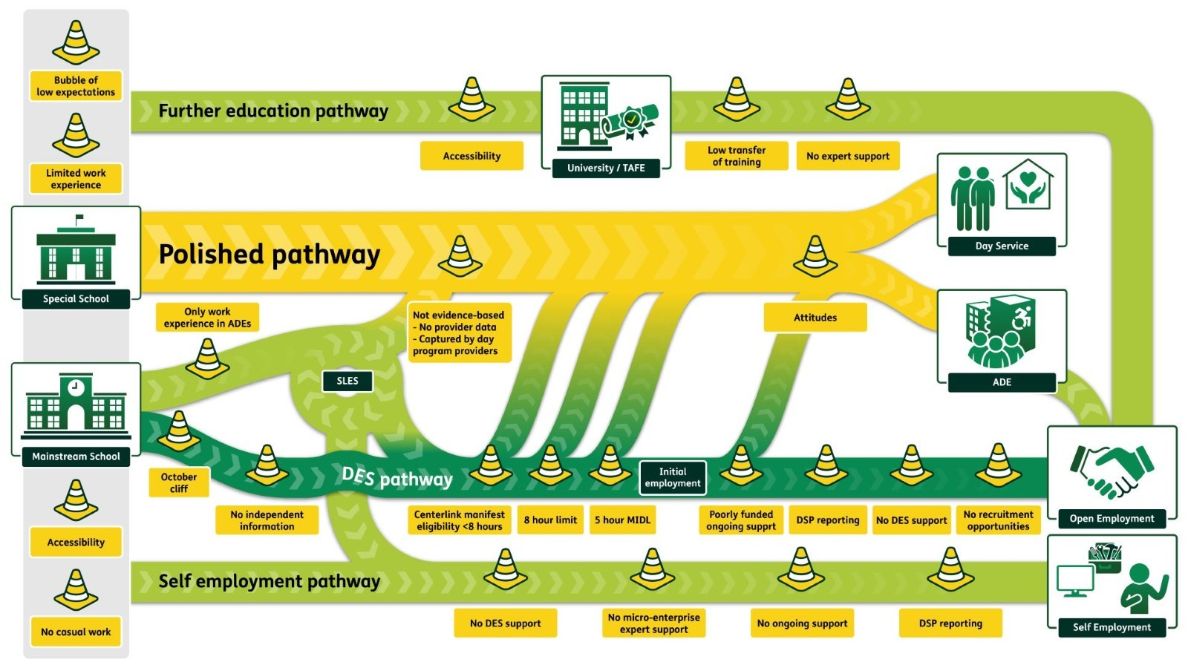

School
Lots of people do some kind of unpaid work experience and have their first paid job while they are at school. Having these kinds of experiences help people to get into jobs when they finish school. But many people with an intellectual disability don’t get to do this, which makes it harder to get into work.
People with an intellectual disability can go to a mainstream school, or be in an education support unit or at a special school. Students at all these kinds of schools should have the support they need to go to unpaid work experience that will let them try out different kinds of jobs.
Students also need to have the kinds of support they need to do an after-school job, like in a supermarket or a fast-food restaurant, but they don’t often get that.
Disability Employment Services (DES) should be able to support people with an intellectual disability with their jobs, while they are at school. DES should also give people with an intellectual disability and their families more information about self-employment.
There is lots of research that says that unpaid work experience and after-school paid work are both really helpful for people with an intellectual disability when getting into work after finishing school. The research also says that unpaid work experience can be helpful for older people with an intellectual disability too.
What we recommend
- People with an intellectual disability have the same opportunities to do unpaid work experience at school as other people.
- DES support is available for all kinds of unpaid and paid work while at school for people with an intellectual disability.
- There is more information about open and self-employment given to people with an intellectual disability and their families while they are at school.
- Work training happens on-the-job, not in a classroom

Transition from school to work
Moving from school into work is an important time for a person with an intellectual disability and their families. Often, the only options they are told about are sheltered workshops, also known as Australian Disability Enterprises (ADEs) and day programs.
There are different kinds of employment supports for people with an intellectual disability when they leave school, but they don’t start until the new year. This leaves a big gap with no support.
The National Disability Insurance Scheme (NDIS) has a program called the NDIS School Leavers Employment Supports (SLES). Many SLES providers put people with an intellectual disability on the polished pathway to a sheltered workshop or a day program instead of into mainstream work. We don’t think this is ok, and want this to stop.
It’s really hard to get independent information about going to work and what kinds of support are available for people with an intellectual disability and their families.
There is lots of research about how people with an intellectual disability learn new information about a job. The best way is at work, not in a classroom.
What we recommend
- Supports from the NDIS are for open and self-employment.
- There is more independent information about different employment supports and work options in open and self-employment.
- No organisation that runs a sheltered workshop or day program can also do school leaver support.

First job - getting in the door, finding a job
For many people with an intellectual disability, getting their first job isn’t easy if they want that job to be in open or self-employment. There are several barriers that made this harder including:
- Assessments
- Getting support from DES and Work Assist
- Getting the right support from the NDIS

Assessments
People with an intellectual disability often have different tests during their lives, that are used to find out if they can use services and support.
These assessments can be stressful and difficult, and don’t recognise the different ways that people with an intellectual disability communicate.
When assessments are used to decide on what kind of work a person with an intellectual disability can do, they can often be wrong. We want assessments to be different, and to focus on what a person with an intellectual disability wants to do, and what support they need.
Job customisation
One of the best ways to make employment work for people with an intellectual disability is to design the job just for them. This is known as job customisation.
This needs lots of skills from an employment support provider, who works with an employer and listens to a person with intellectual disability to build the right job for them.
Getting support from DES
People with an intellectual disability have lots of obstacles in the way of getting support from DES. The DES rules say they will only support people who can work more than 8 hours a week, but lots of people with an intellectual disability work less than that.
The DES system isn’t very flexible which doesn’t work well for people with an intellectual disability.
Getting support from the NDIS
There are some employment supports in the NDIS that are mostly used for people with an intellectual disability who work in ADEs. It’s not easy to use these supports for work in open and self-employment.
Support for older people with an intellectual disability
There are lots of older people with an intellectual disability who have not worked in open or self-employment for many years, or who want to move out of working in an ADE. We think there should be specific support for them.

What we recommend
- DES uses a different way to find out what a person with an intellectual disability wants to do at work, and the kinds of support they need.
- All people with an intellectual disability are eligible for DES support.
- DES support for older people with an intellectual disability.
- Independent information about all the different kinds of supports that are available in DES and in the NDIS.

Starting at work
Everyone needs support when they start a new job, including people with an intellectual disability.
Part of starting a new job is working out the best ways to get there and home again, which might mean learning how to catch public transport, learn a new public transport route, catching a taxi, or ride sharing.
The information about a new workplace needs to be accessible for people with an intellectual disability, and they need enough time to learn this new information.
Research has found that having a buddy at work can help to feel more comfortable, along with support from a manager and feeling included.
What we recommend
- Information about using NDIS supports to get to work is at all DES.
- More information about starting a new job in accessible formats is available.

Staying at work and ongoing support
People with an intellectual disability often need support to do their job for a long time. Both DES and the NDIS can do that support, but it can be confusing to know which one is doing what.
In the current DES system, people with an intellectual disability don’t get the right kind of flexible on-going support. We want that to change. DES needs to give the right supports depending on what is happening in the life of a person with an intellectual disability.
The NDIS supports at work mostly are used for ADEs, and we want them to be used in other kinds of work. The NDIS and DES also need to work out what each group supports so that isn’t so confusing.
There are specific payments that DES can get for giving people with an intellectual disability ongoing support, but they don’t last long enough, and aren’t flexible.
There is also a payment for extra support for people with a moderate intellectual disability, and we want more people to be able to get that, including if they can work less than 15 hours per week.
What we recommend
- All people with an intellectual disability get long term, flexible ongoing support, no matter how many hours they work.
- The NDIS and DES work together to make it clear who does what with employment support.
- There is more information for DES about what good ongoing support looks like.

Changing jobs, changing lives
The lives of people with an intellectual disability can change, and they might want to change jobs. The supports they get from DES and the NDIS need to also change. DES should be able to change the support they give to people with an intellectual disability when it is needed.
What we recommend
Both DES and NDIS are more flexible when needed.

