11 April 2022
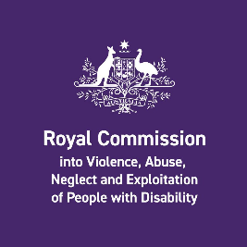 | In April 2022, the Disability Royal Commission will talk about Australian Disability Enterprises.
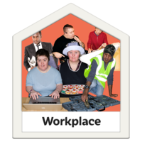 | These are also called ADEs or sheltered workshops.  Most people who work in an ADE have an intellectual disability.
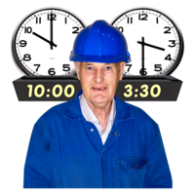 | People with disability work hard in their jobs.  Some people work long hours.  They are proud of their work.
 | Some people who work in ADEs get paid just $2.50 per hour.
Inclusion Australia does not think this is fair.
We think everyone should be paid properly for work that they do.
Our Voice is a committee which gives advice to Inclusion Australia.
All the members are people with an intellectual disability.
Our Voice members said this about ADEs:
“People with disabilities have the right to work in the open market like anyone else and get the training and support they need.”
“This means no more sheltered workshops.”
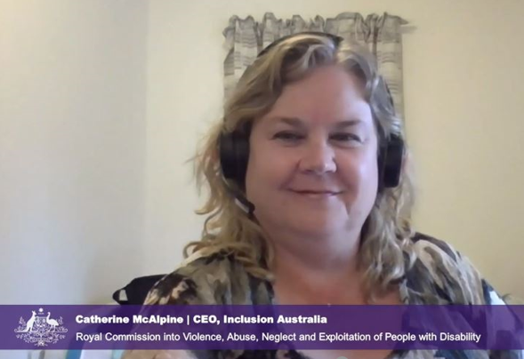 | Our CEO Catherine McAlpine will talk to the Royal Commission on 11th of April.  She will tell them what people with intellectual disability want to change with ADEs.
We think it should be easier for people with intellectual disability to work in open employment.
Open employment is when people with and without disability work together in regular jobs.
We think there should be a plan to change ADEs to help people find open employment.
This plan should be co-designed with people with a disability, families and advocates

 | We want to tell as many people as possible about ADEs and what needs to change.
It is time to make ADEs fair for everyone.
This means paying people properly for their work.
Equal pay means equal respect.

Tell people how you feel on social media.
Use the Hashtags #EqualPayEqualRespect and #LowPayNoWay so that more people hear what we all have to say.

