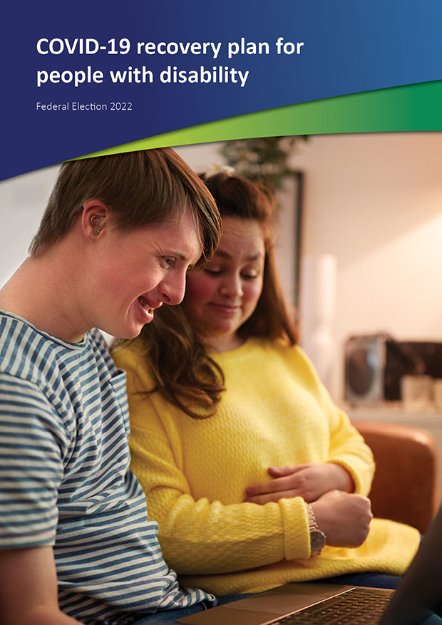

Introduction
People with disability have experienced fear, illness, isolation, neglect and death over the two years, with our needs often forgotten during COVID-19.
COVID-19 has had a greater impact on our community than others, and most particularly on First People with disability, migrants and refugees with disability, and people with disability in congregate settings.
COVID-19 has worsened many of the inequalities our community faces, but has also shown that more accessible services are possible.
The Disability Royal Commission has held two public hearings (public hearings 5 and 12) into the management of COVID-19 and the vaccination rollout for people with disability, and is now looking into the response to Omicron. They have made many recommendations since 2020, but few have been implemented.
Australia’s national disability organisations have also made a series of evidence-based recommendations that have been ignored.
Two years after the pandemic began, now is the time to support people with disability, our families and caregivers, and organisations, as we rebuild our lives and look to the future.
COVID-19 isn’t over, and for many people with disability, the current lifting of public health measures is causing significant distress. People with
disability need significant support to stay safe with so much COVID-19 in the community.
There are also people developing post-viral disability, known as long COVID-19, who need support.
We are calling for the development of, and investment in, a COVID-19 Recovery Plan for people with disability that addresses the harm caused to our community, puts in place a blueprint for the future, and addresses the needs of those with long COVID-19.

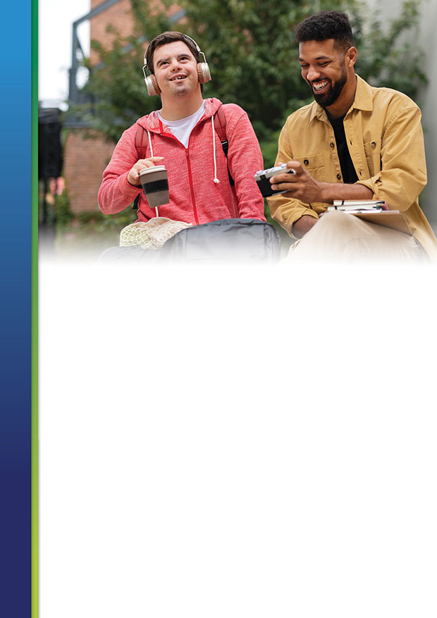
=

What we want
People with disability need a COVID-19 Recovery Plan. We want the plan to address the harm caused to our community, put in place a blueprint for the future, and address the needs of those with long COVID-19.
A COVID-19 Recovery Plan for people with disability will:
- Helps us recover from the past two years
- Provides the ongoing support we need to stay safe from COVID-19
- Supports people with Long COVID-19
We call on all political parties to commit to this COVID-19 Recovery Plan to ensure people with disability aren’t left behind.
The COVID-19 Recovery Plan will cover:
- Health
- Accessible information
- Education and employment
- Disadvantage and poverty
- COVID-19 in segregated and institutional settings
- Outreach
- Data collection and research
- The Disability Royal Commission

This plan has been developed by key national disability representative organisations.
Australian Federation of Disability Organisations Children and Young People with Disability Australia First Peoples Disability Network Australia
Inclusion Australia Disability Advocacy Network Australia
National Ethnic Disability Alliance People with Disability Australia Women with Disabilities Australia

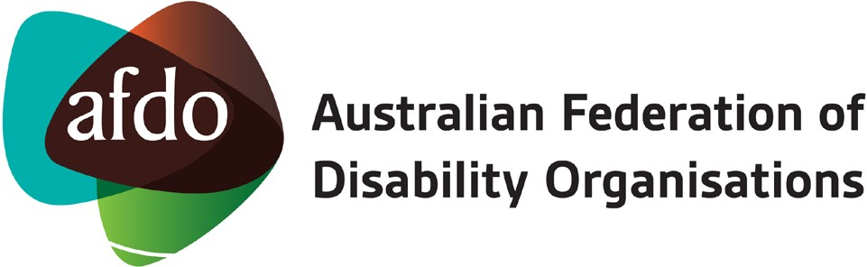

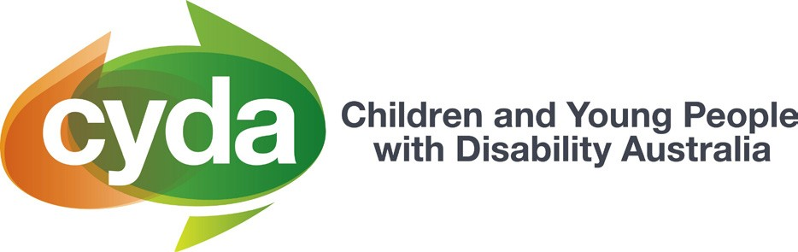

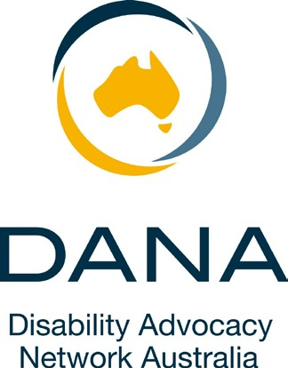

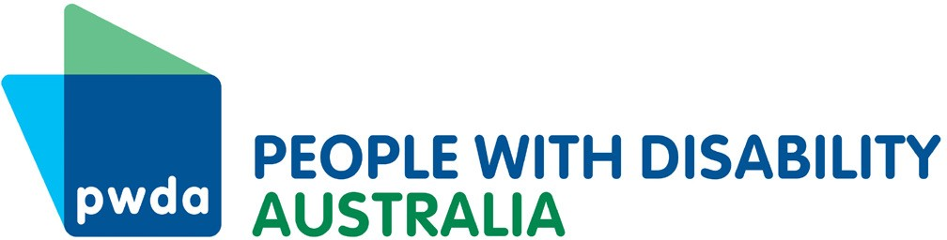

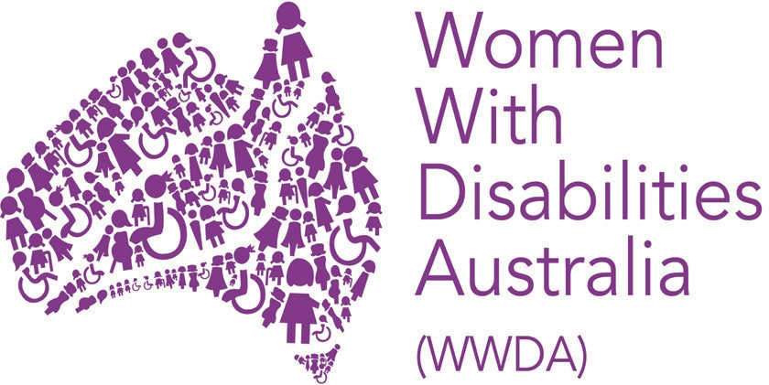

Health
The national Department of Health has been found in two Disability Royal Commission hearings to have ignored and deprioritised the needs of people with disability during COVID-19. The federal Department of Health needs
to urgently dedicate resources to addressing and understanding the health needs of all people with disability.

We want the Australian Government to:
- Establish a dedicated disability unit in the Department of Health to review the COVID-19 response for people with disability, coordinate and develop a COVID-19 safety plan for people with disability, and establish supports for people with long COVID-19.
- Develop, with state and territory health departments, a rights-based ethical framework for the treatment and triage of people with disability, including First People with disability, including adopting the
recommendations from the following documents: Statement of Concern on COVID-19 Human Rights, Disability and Ethical Decision-making and COVID-19: Ethical Decision-Making for First Peoples Living
with Disability.

- Ensure First People’s health facilities are provided with resources to deal with an outbreak of COVID-19, and staffed appropriately.
- Increase allied health support for people with disability (increase to Chronic disease GP Management Plans and increase eligibility to people with disability) to address any rehabilitation needs after two years of COVID-19.
- Provide mental health support for people with disability (increase to Mental Health Treatment Plan number of sessions) to address impacts of long isolation in particular.
- Fully fund the National Roadmap for Improving the Health of People with Intellectual Disability.
- Funding for GPs to do comprehensive health checks for people with disability.
- Expand access to telehealth, including removing requirement for having to visit in person every 12 months.
- Provide a comprehensive planning and program to ensure every person with disability can access vaccinations, including boosters, including at- home vaccinations.
- Provide free, available and priority access to PPE and RATs and PCR tests.
- Provide free and available in home and walk in testing in accessible venues.
- Develop funding and evidence-based resources for GPs, such as Medicare support for longer appointments, to screen for post-viral impact of COVID-19.
- Implement long COVID-19 specialist outpatient clinics bringing together all specialists required, including allied health, in each capital city, and funding for clinics to travel to regional, rural and remote areas.

Accessible information
Much of the information available during the pandemic has not been accessible or relevant to people with disability. Much of the burden of translating and sorting information has fallen on under-resourced groups of people with disability. It is long past time that the Australian Government provide accessible information in a timely and accurate way.

We want the Australian Government to:
- Develop guidelines about accessible information for people with disability in emergencies, including COVID-19, co-designed with people with disability from diverse backgrounds.
- Provide translations of communications to ensure culturally and linguistically diverse people with disability have access to information in community languages about COVID-19 and vaccinations.
- Commit to the provision of interpreters and in-language counsellor support services including in Auslan.
- Provide timely information in Easy Read format.
- Commit to providing access to medical practitioners who speak the person with disability’s language, including Auslan.
- Provide culturally tailored information and communication on where to access support services.
- Use community radio and translated materials in simple language for critical public health messaging.

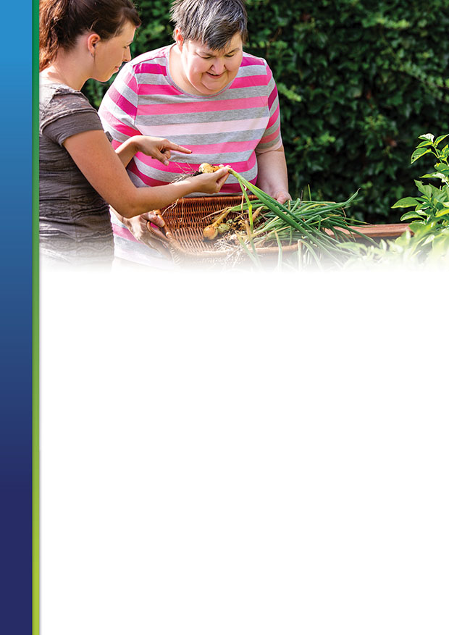

Disability services
Many people with disability and their families struggled to get the services they needed during COVID-19, and there isn’t a plan in place for how this will be fixed while COVID-19 continues. Disability service providers have had two years to plan for COVID-19, and now it is time to ensure this happens.

We want the Australian Government to:
- Mandate COVID-19 emergency planning for all disability service providers.
- Mandate disability supports continuing when COVID-19 occurs.
- Conduct a NDIS Quality and Safeguards inquiry into restrictive practices use in disability services during COVID-19.
- Introduce NDIS funding for people with disability to do individual emergency planning, including for COVID-19.
- Adequately fund individual disability advocacy services to do outreach and provide COVID-19-and-vaccination information and support to the most marginalised people with disability in the community.
- Implement all Disability Royal Commission public hearing 5 and 12 recommendations.

Education and employment
Students with disability have been left behind during the COVID-19 pandemic. The impacts of the lack of reasonable adjustments throughout the pandemic means many students did not receive education an equitable basis as their non-disabled peers. This is likely to have long-term impacts.
Young people with disability are one of the most disadvantaged cohorts in the labour market because of the complex and multi-layered barriers they experience. They are likely to experience a scarring impact from the pandemic through disrupted post-school transitions.
Many people with disability will need to continue to isolate, and require flexible work and learning opportunities.

We want the Australian Government to:
- Develop a National Inclusive Education Strategy to ensure the wrongs of the pandemic are never repeated and ensure rights to inclusive education are enacted.
- Ensure students with disability can continue to access education remotely if they request it.
- Conduct further consultation and co-design with young people to inform the reform of disability employment services.
- Invest in research to determine what service model best supports young people with disability to secure and maintain meaningful employment.
- Resource the Australian Human Rights Commission to ensure that flexible work arrangements are available for workers with disability.
- Ensure that workers with disability are entitled to continue to work from home if they request it.

Disadvantage and poverty
Many people with disability live in poverty, with the COVID-19 pandemic making this worse. Surveys from national disability organisations found that the cost of dealing with the pandemic was leading to people with disability having to choose between food and COVID-19 safety.

We want the Australian Government to:
- Address existing disadvantages and poverty for people with disability, including lifting the rate of the Disability Support Pension immediately.
- Suspend all mutual obligations and activities that will expose people with disability on an income support payment to COVID-19.
- Address the housing crisis for First People with disability, particularly in rural and remote communities, to reduce over-crowding, to ensure quality and working hardware (such as taps, showers, plumbing) is present and maintained, and cooling and heating is available when
needed. In addition, government must supply communities with access to clean running water where there is none, as a matter of urgency.
- Increase the supply of affordable, accessible contemporary housing.
- Address food security for rural and remote communities, and ensure people with disability have access to food and nourishment.
- Make sure immediate alternative housing arrangements are available to ensure that people are able to safely isolate if infected with COVID-19, or if they are a close contact.
- Provide financial aid for international students with disability, or an extension of their time of study or visas, without cost.
- Ensure employment assistance and housing support for people with disability on temporary visas, including international students.

Safeguarding from all forms of violence
During the COVID-19 pandemic, people with disability have experienced increased rates of violence, abuse, exploitation and neglect due to a range of reasons such as stress, uncertainty, dependence on others and periods of isolation. Within our community, women and girls with disability, and people with disability living in institutional settings, have been particularly
targeted during the pandemic, with evidence showing that many individuals have been locked up against their will, denied their rights to access support services, and had money, friends, family and even food restricted to them in the name of lockdown measures.

We want the Australian Government to:
- Conceptualise and recognise that segregation of people with disability – in all its forms – is a violation of people’s fundamental human rights and is an abhorrent ideology with resultant practices that contravene the Convention on the Rights of Persons with Disabilities (CRPD) and other human rights treaties to which Australia is a party. Instead, implement
a national, time-bound strategy and framework for the closure of all segregated settings and environments, including those operated by non-government organisations and the private sector.
- Ensure emergency accommodation, and domestic and family violence services are accessible and equipped to support women and girls with disability, especially during pandemic circumstances.
- Resource the NDIS Quality & Safeguards Commission to take a more proactive role in ensuring quality and safeguarding for National Disability Insurance Scheme participants.
- Adequately fund disability residential services to manage the impact of the COVID-19 pandemic, similar to the $458.1 million funding package earmarked in the 2022–23 Federal Budget.

COVID-19 in segregated and institutional settings
People with disability who live in institutional settings are at very high risk from COVID-19, and have faced barriers to getting information and vaccinations. People with disability who live in group homes, aged care
facilities, boarding houses, mental health facilities, hospitals and prisons all need specific resources to stay safe from COVID-19, as do people who work in Australian Disability Enterprises.

We want the Australian Government to:
- Urgently complete all vaccination and booster programs for people with disability in institutional settings.
- Provide specific resources to manage COVID-19 outbreaks without relying on increased restrictive practices, including in prisons.
- Increase funding for individual disability advocacy services to reach out to all segregated and institutionalised settings in their regions.

Outreach
Many people with disability have spent much of the past two years very isolated and alone, trying to stay safe from COVID-19. Disability organisations can reach out to them with resources and provide peer support, as well as connect them with disability and mainstream services.

We want the Australian Government to:
- Urgently resource disability organisations to connect with and support people with disability who live alone and who have had to isolate for long periods of time, particularly through funding culturally relevant and appropriate organisations for First People with disability, migrant and refugee people with disability, and people with disability who live in congregate settings.

Data collection and research
The two Disability Royal Commission hearings and reports (public hearings
5 and 12) have found that data collection about people with disability during COVID-19 has been very poor, including about people’s vaccination rates.
We need better data about what has happened to people with disability during COVID-19, to inform future decisions.

We want the Australian Government to:
- Implement the Disability Royal Commission recommendations about data collection from public hearings 5 and 12.
- Improve and publish data about COVID-19 experiences and deaths for all people with disability, including people not receiving NDIS supports.
- Disaggregate the data collected about First People, culturally and linguistically diverse people, women, LGBTIQA+ people with disability and people with intellectual disability, children and young people.
- Fund dedicated research via the National Disability Research Program, including evidence and data collected about the impact of COVID-19 on people with disability and their families and caregivers, led by people with disability.
- Conduct research into impact of individual and systemic advocacy during COVID-19 and the effect of the pandemic on the advocacy services provided, including sharing a snapshot of demand for services.
- Action data collected about people with long COVID-19.

Disability Royal Commission
COVID-19 has had a big impact on the capacity of the Disability Royal Commission to do the job they have been entrusted with. We believe the commission needs to be extended so the royal commissioners can continue their examination of the violence, abuse, neglect and exploitation we experience, including during COVID-19.

We want the Australian Government to fund and extend the DRC by two years so the commission can:
- Conduct a culturally and linguistically diverse public hearing, hear safe, supported and advocated individual submissions, and
examine the full extent of the pandemic’s impact on culturally and linguistically diverse, migrant and refugee, and emerging communities of people with disability.
- Ensure the broad terms of reference for the commission are fully investigated, given the disruption of the pandemic.
- Advocate for funding extensions for Disability Royal Commission support services and systemic advocacy.

