Doing research and projects with people with an intellectual disability

This form is for researchers and consultants who want to work with people with an intellectual disability.

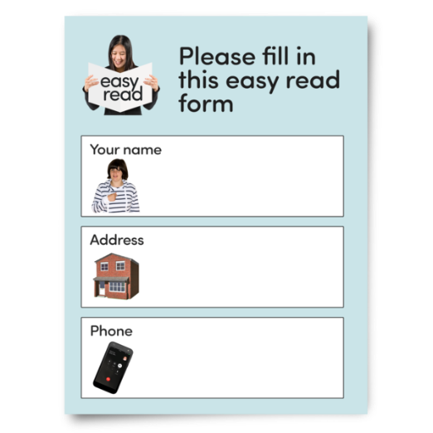 | These questions will help you think about your project in a more accessible way.
 | Your answers will help us to talk about your project with people with an intellectual disability.

Things we need to know
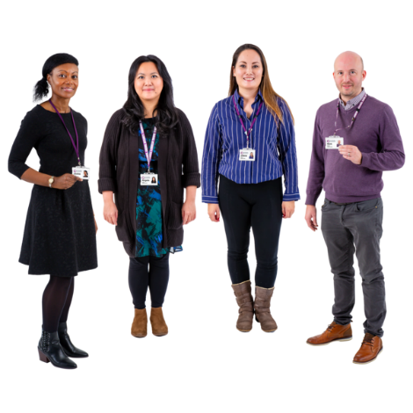 | Who are you?
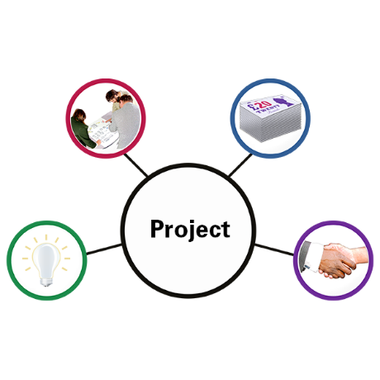 | What is your project about?
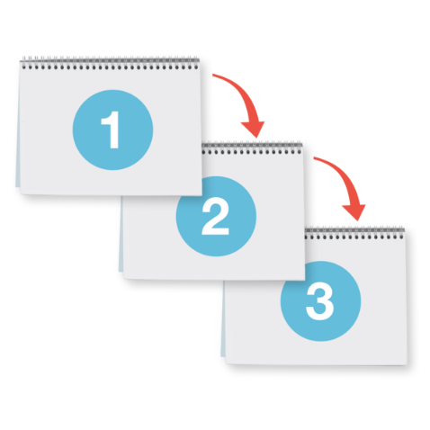 | What will your project do?
 | How will your project be good for people with an intellectual disability?

Who do you want to talk to?

Why do you want to talk to them?

What questions do you want to ask?
When do you want to talk to them?

Where will you talk?
- online
- in person
- in a survey
How will you make the talk accessible?
Do you want to talk to people individually, or in groups?

Do you want to talk once or many times?

Will you pay people for talking to you?

How much?

How will you pay people?
For example, through cash, vouchers, or some other way.

What will happen with the information that people give you?

Will you keep the information private?
What support will you provide?

Will you pay for personal support if people need it?

Is your project about anything that might be upsetting for people?
What support will you give people to feel safe if they speak with you?

How will you tell the people involved what you find out?
How will you make that accessible?

What help do you need from Inclusion Australia?
Is there any other information you want to tell us?

© Inclusion Australia 2022

