Make Decisions Real

5 Steps of Supported Decision Making
Video Activity Booklet

This Activity Booklet belongs to:
__________________________________________________________________

How to use this activity booklet Page 4

About Make Decisions Real Page 6

What is supported decision
making? Page 7

The 5 Steps of Supported
Decision Making Page 9

1: Explore the decision Page 10

2: Involve the right people Page 15

3: Think about options and consequences Page 20

4: Make the decision real Page 25

5: Reflect on what happened Page 29

How to use this activity booklet

There are 6 Make Decisions Real videos. Each video shows a different step in the supported decision making process.

The videos show people with an intellectual disability talking about how they do supported decision making in their own lives.

It is a good idea to watch the videos in order from Step 1 to Step 5.

You can watch the videos with your decision supporter if you like.

At the end of each video there are some questions for you to think about and answer.

You can write or draw your answers in this activity booklet.

There are also some blank pages at the end of this booklet.
Use these pages to write or draw your ideas or to help you plan your answers.

We hope you enjoy the videos and they help you learn more about supported decision making.

About Make Decisions Real
Make Decisions Real is a project by Inclusion Australia.

The project helps people with an intellectual disability and their supporters learn about supported decision making.

Supported decision making means making your own decisions with the right support.

Make Decisions Real is funded by an Information, Linkages and Capacity Building grant from the Australian Department of Social Services.
What is supported decision making?

Everyone has the right to make their own decisions.

We all make decisions every day.
Some decisions are big. Some decisions are small. But they are all important.

Supported decision making means making your own decisions with good support from people you trust.

Supported decision making is important because it means you get to choose how you want to live your life.

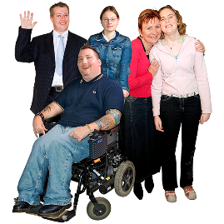
We spoke to people with an intellectual disability and their supporters around Australia about making decisions.

We also looked at supported decision making resources that were already out there.

We found that most of the resources were made for decision supporters, not for decision makers.

Some of the resources were confusing and had hard words.
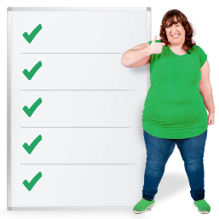
We came up with 5 easy steps to help you put supported decision making into practice.

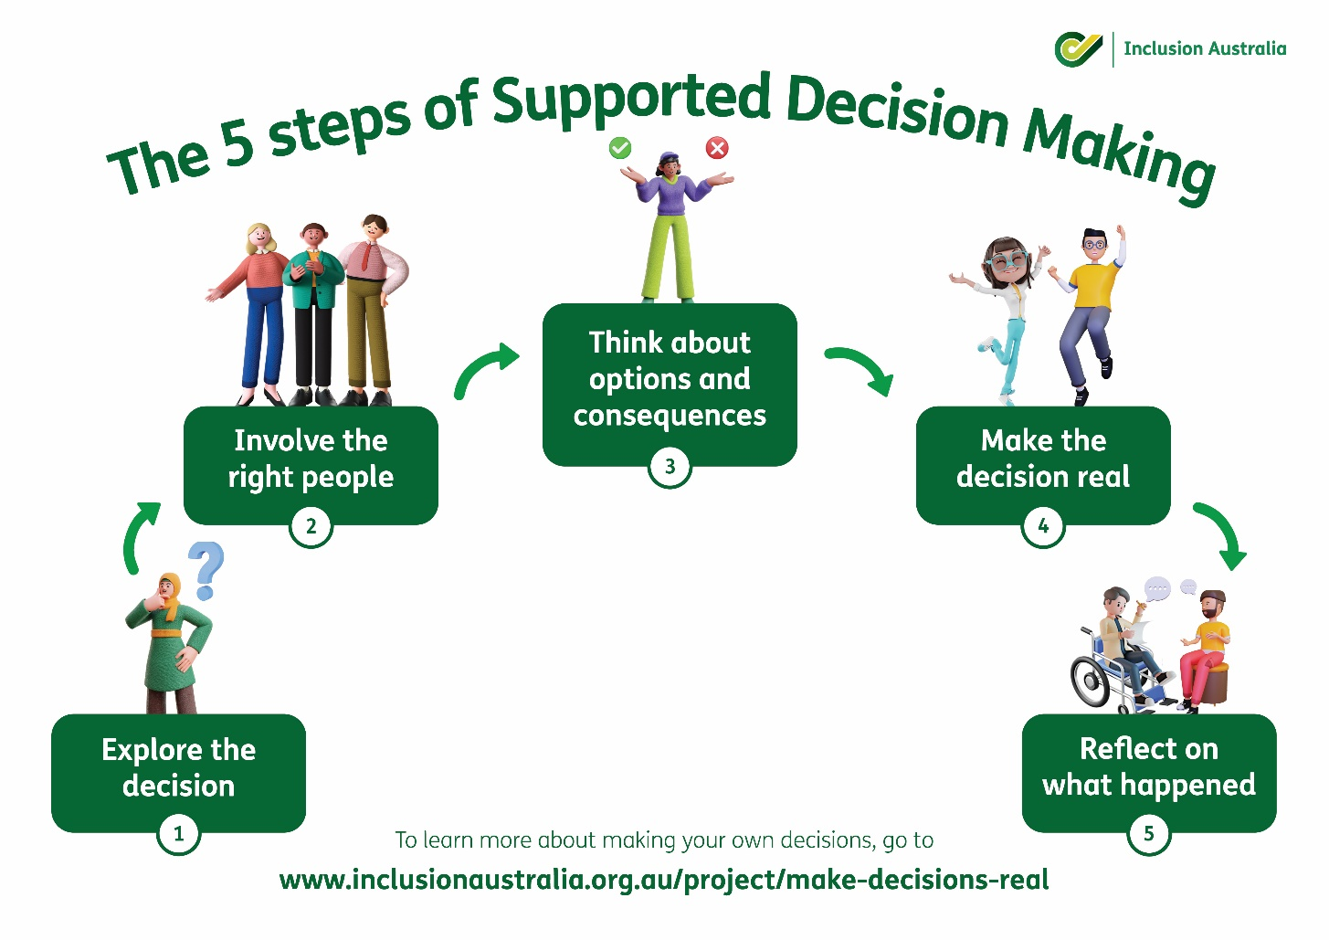

When you are ready to watch the videos, turn the page to start with Step 1: Explore the decision
Step 1: Explore the Decision

Exploring the decision means really thinking about the choice you want to make and finding out what the decision really means to you.

You can explore your decision by asking yourself some questions

• What is the decision?

• Why does the decision matter to me?
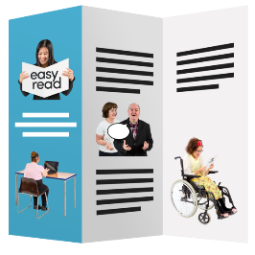
• What will happen if I make this decision?

• Do I have all the information I need to make my decision?

Things to remember:

- Exploring the decision means thinking about the choice you want to make and working out what the decision really means to you

- It is a chance for you to get more information about your decision

Watch the video for Step 1, then answer the questions
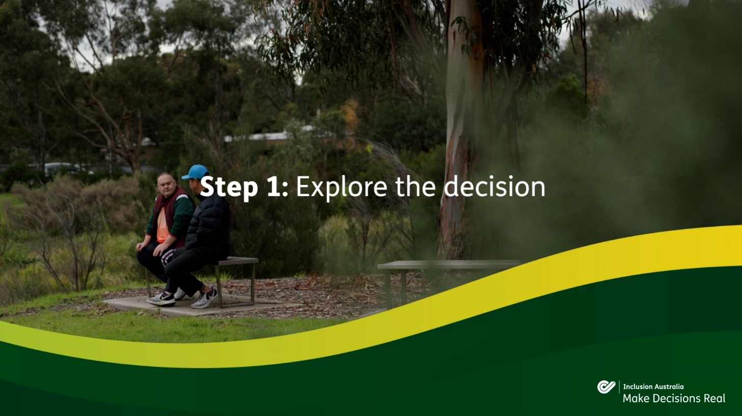

https://youtu.be/nXIM68y4lBU

What is a decision you are thinking about making?
Write or draw your answer here.

Is it an easy decision or a hard decision?

Easy

Hard

If it is a hard decision, what makes it hard?
Write or draw your answer here.

How do you like to get information when you are thinking about a decision? Tick any boxes that are true for you.

I read information

I watch videos or films about it

I go somewhere to ask questions, for example the Post Office.

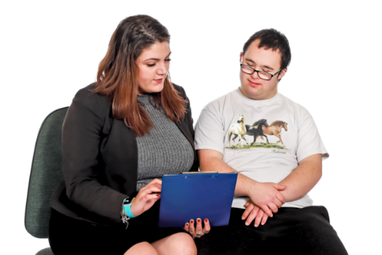

I ask someone I trust

I look on the internet

Step 2: Involve the right people
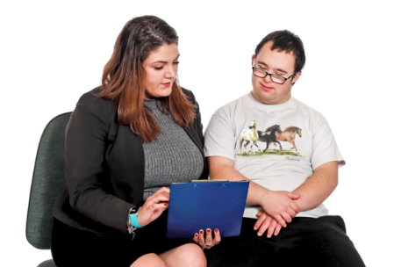

Involving the right people means getting the right support to make your decision.

A good decision supporter will help you to make your own choices.

They won’t let their opinion affect your decision or try to make the choice for you.
You might have different supporters for different types of decisions.

Some decisions might need more support than others and that’s okay!

Things to remember:

- Involve the right people means getting the right support for the decision from people you trust

- A good decision supporter helps you make your own decisions and doesn’t try to make the choice for you

Watch the video for Step 2, then answer the questions

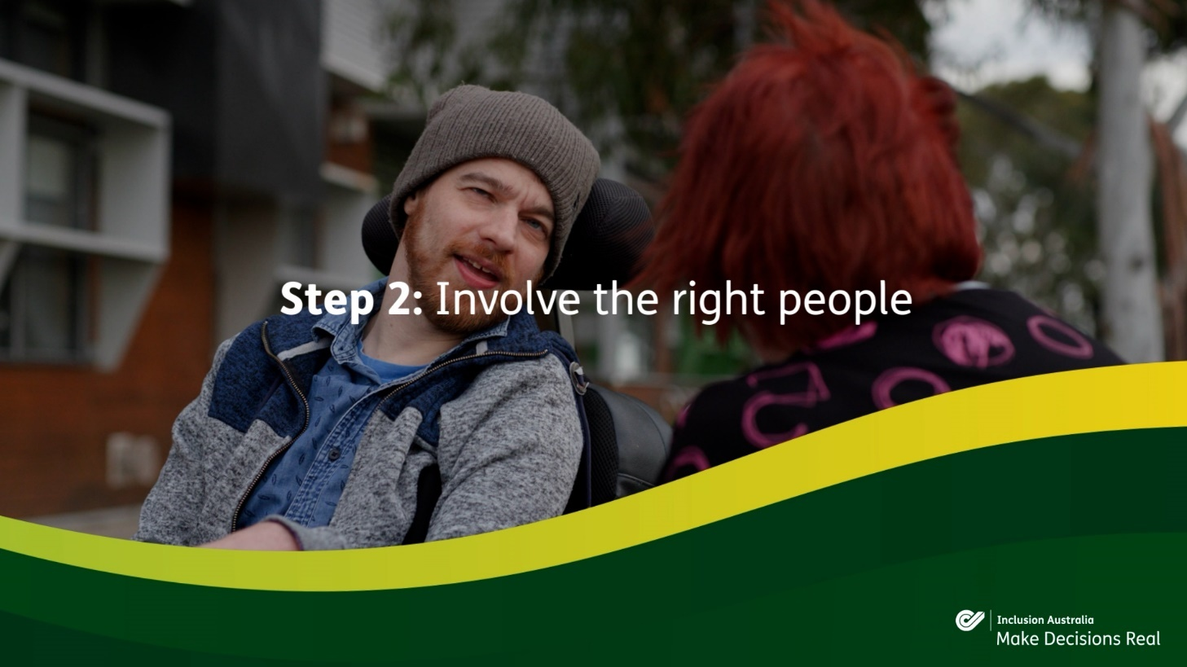

https://youtu.be/149GRxRuf40

Do you like to be supported when you make decisions?

Yes

No

If Yes, who supports you when you make decisions?
Write or draw your answer here.

It is important for my decision supporters to be:
Tick the boxes you think answer the question best, or you can write or draw your own answers.
Honest | Helpful
Bossy | Boring
Mean | Friendly
Thoughtful | Has good information

Write or draw your own answers here.

Step 3: Think about options and consequences

It is important to think about the options and consequences of your decision.

Consequences are things that might happen if you make the decision.

You can think about this by asking yourself some questions about the decision
- Can I afford to do it?

- Do I have enough time to do it?

- Who else will my decision affect?

Another thing to do is weigh up any risks of the decision.

This is where you think about all the good things and any bad things about a decision to help you decide.

A good way to weigh up the risks of a decision is by making a Pros and Cons list.

You can ask your decision supporter to help you think about the risks.

Things to remember:

- Thinking about options and consequences means asking yourself some questions about the decision and weighing up any risks

- You can ask your decision supporter to help you weigh up and manage the risks if you want

Watch the video for Step 3, then answer the questions
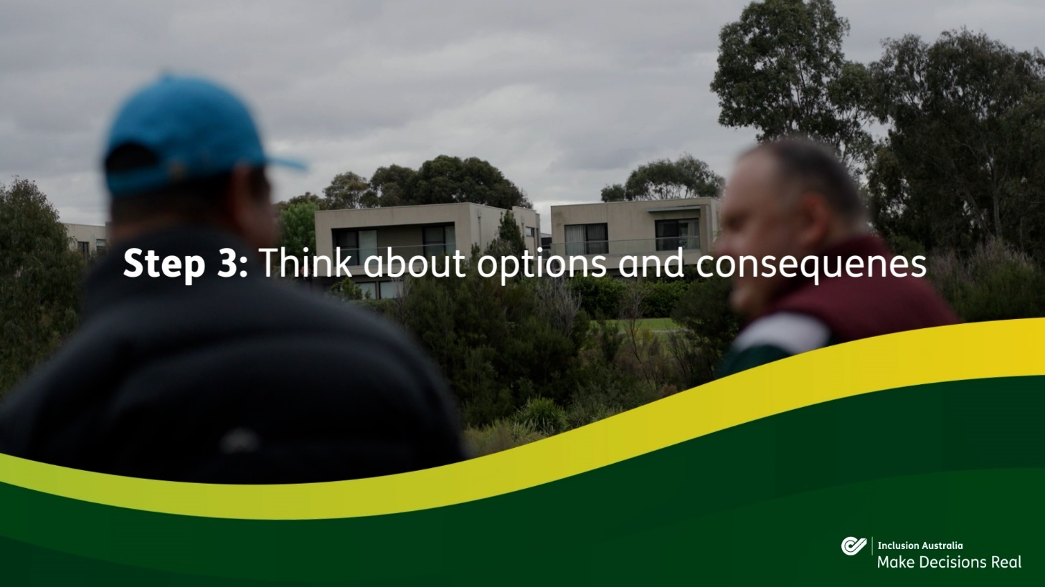

https://youtu.be/WDrRxGJrCyU
How do you think about risks when you make decisions?
Write or draw your answers here.

Have you ever made a decision that went wrong?

Yes

No

What did you learn from your decision?
Write or draw your answer here.

Step 4: Make the decision real
Making the decision real is the fun part!

This means putting your plan into action and making your decision happen.

You can ask your decision supporter for help with making your decision real if you want.

Things to remember:

- Making the decision real means putting your plan into action and making your decision happen

- You can ask your decision supporter for help to make your decision real if you want

Watch the video for Step 4, then answer the questions
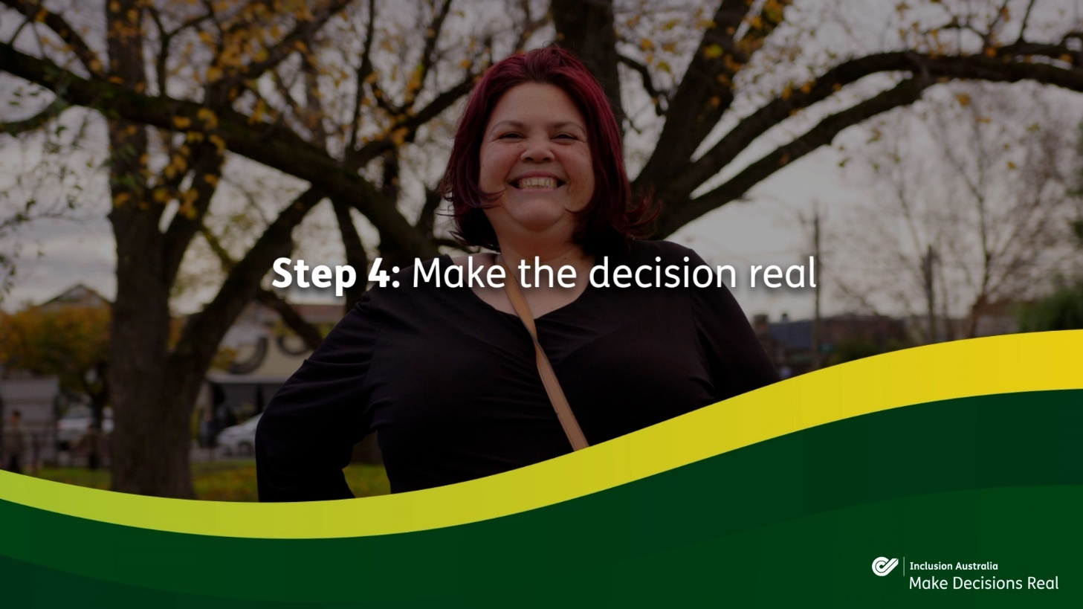

https://youtu.be/EJWfCJEwpyY

What is a big decision you made recently?
Write or draw your answer here.

How did you make your decision happen?
Write or draw your answer here.

Who supported you to make your decision?

My family

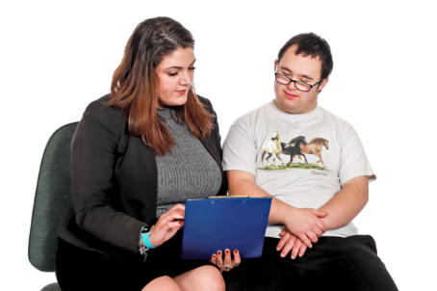

My support worker

_________________________
How did they support you?
Write or draw your answer here.

Step 5: Reflect on what happened

Reflecting on what happened means looking back on your decision and thinking about how it went.

You can ask yourself some questions about your decision
- What went well?
- What didn’t go so well?
- Was it different from what I expected?
- What can I learn from my decision?

You can ask your decision supporter to help you reflect on your decision if you want.

Reflecting on what happened helps you become more confident at making your own decisions.

Things to remember:
- Reflecting on what happened means looking back on your decision and thinking about how it went

- Reflecting on your decision helps you become more confident at making your own decisions

Watch the video for Step 5, then answer the questions
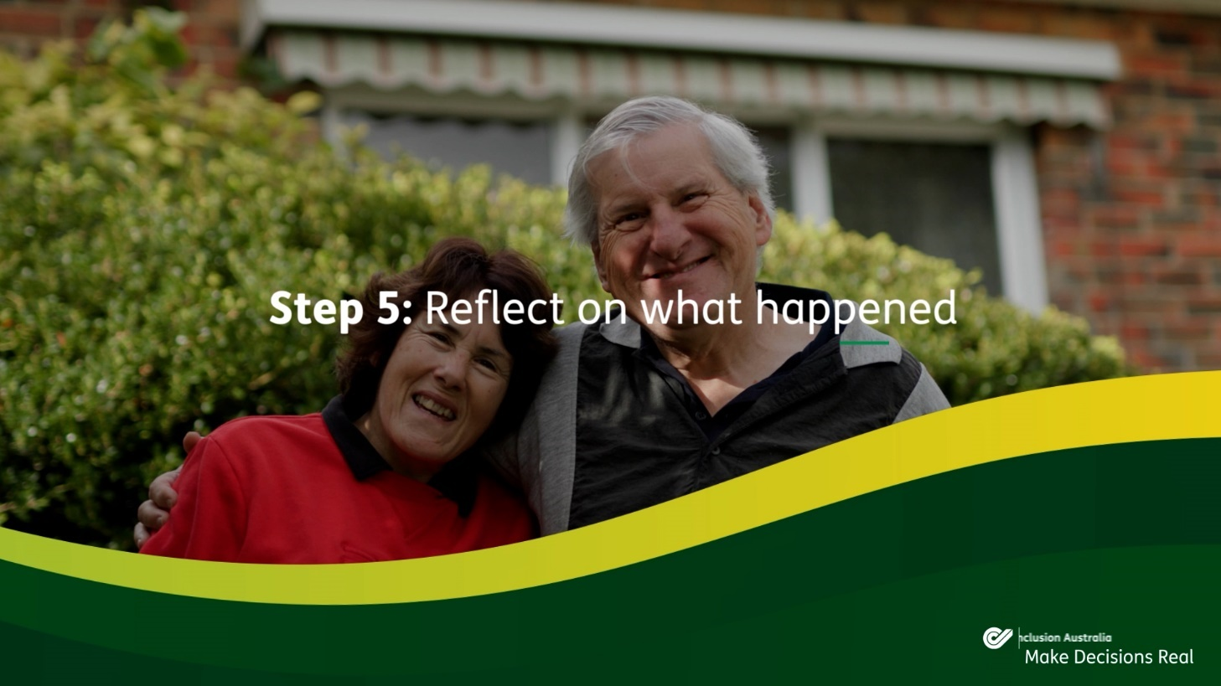
https://youtu.be/lReJlWMemPs
Have you reflected on a decision before?

Yes

No

Think about a decision you made recently.
What went well with your decision?
Write or draw your answer here.

What didn’t go so well?
Write or draw your answer here.

What did you learn from your decision?
Write or draw your answer here.

How were you supported to reflect on your decision?
Write or draw your answer here.

Notes

About Inclusion Australia
Inclusion Australia is an organisation that represents the rights and interests of people with an intellectual disability and their families in Australia.​
​

We run projects and activities that support the rights of people with an intellectual disability.​

To learn more about Inclusion Australia
www.inclusionaustralia.org.au

You can follow Inclusion Australia on Facebook
www.facebook.com/inclusionoz

and Twitter
www.twitter.com/inclusionoz

