Our Submission to the 2022 Election Inquiry
 | This is an Easy Read version of an Inclusion Australia submission.
 | A submission is when we write to the government and tell them what we think.
 | This submission was for the Inquiry into the 2022 federal election.
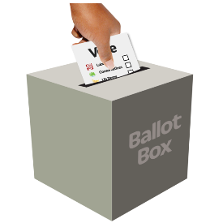 | The Inquiry into the 2022 federal election looked at how everything went when we voted for a new Australian government in 2022.

What did we say?
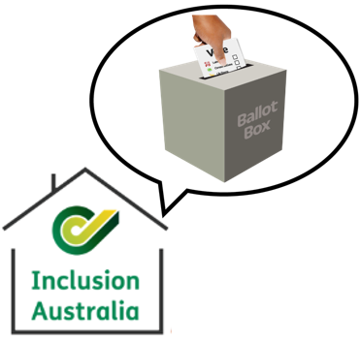 | We told the government about voting issues for people with an intellectual disability.
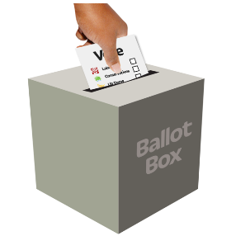 | People with an intellectual disability have the right to vote and have a say about the government.
 | Many people with an intellectual disability do not get to vote.
The United Nations Convention on the Rights of Persons with Disability tells us about the rights of people with disabilities.

We call it the CRPD for short.
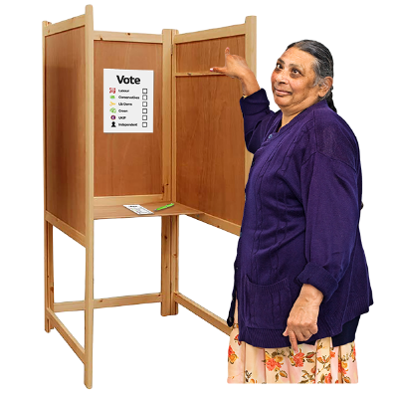 | Article 29 of the CRPD says that people with a disability have the right to be part of voting just like everyone else.
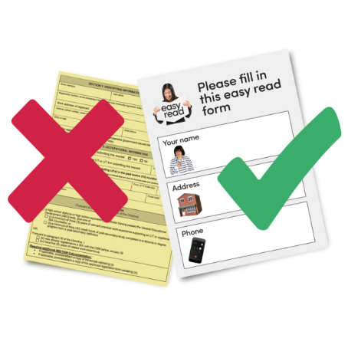 | This means that people with a disability have the right to  - Vote in a way that is easy to do and understand.  - Vote in secret.  - Have voting support in the way they want and when they need it.
 | Australia is not doing what the CRPD says about voting.
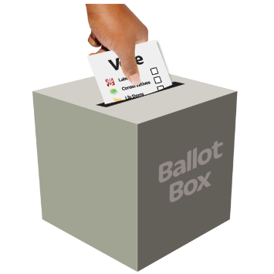  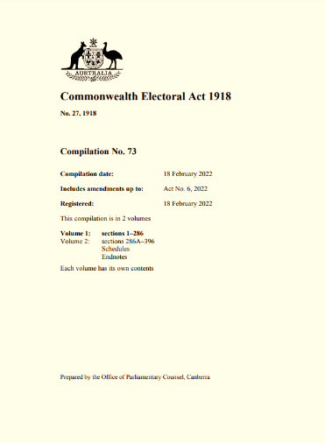 | Many people with intellectual are not allowed to vote because of an old law from 1918.
The old law says people have an intellectual disability may not be able to vote because of what they call ‘unsound mind’.

This is unfair and rude.

 | This unfair law is being used often to stop people with an intellectual disability from voting.
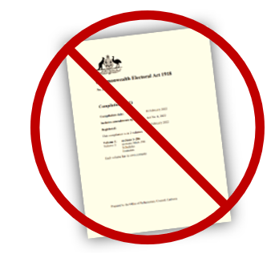 | Australian Lawyers for Human Rights wrote a letter in 2022 about changing the old law.
 | Inclusion Australia and 60 other organisations signed the letter to say we agree.
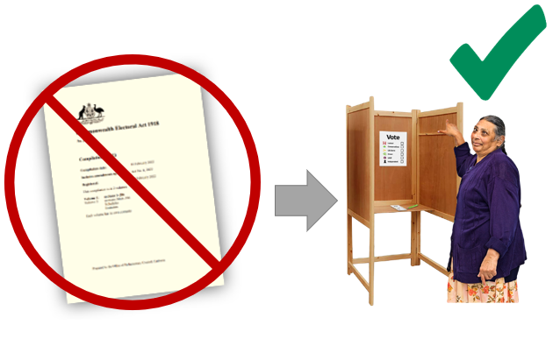 | The law needs to change so people with intellectual disability can have their right to vote.
 | A group called the Australian Law Reform Commission shared ideas for how to change the law in 2014.
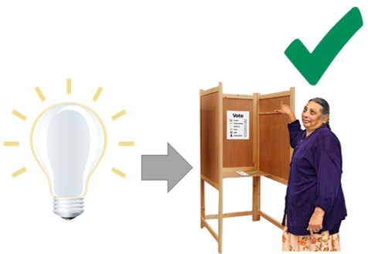 | The government should use these ideas to change the law.

