Our submission to the NDIS Review on supporting parents with an intellectual disability

This is an Easy Read version of a submission.

A submission is when we write to the Government and tell them what we think.
This submission was written by the National Advocacy Collective.
The National Advocacy Collective is a group of organisations that support the rights of parents with intellectual disability in Australia.

Our submission told the NDIS Review what we think about NDIS supports for parents with an intellectual disability.

The NDIS Review will help the Government find out
- What works well in the NDIS

- What needs to change in the NDIS.
You can find the big version of our submission here.

Parents with an intellectual disability
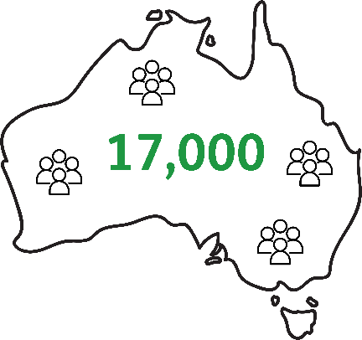 | There are about 17,000 parents with an intellectual disability in Australia.
 | Parents with an intellectual disability can face more problems than most people.
Parents with an intellectual disability are more likely to

- have trouble paying for everyday things like rent and food

- depend on Government payments like the Disability Support Pension

- have trouble finding and keeping a job

- have their kids taken away by child protection services.

Many parents with an intellectual disability also

- have a hard time getting good parenting support

- have trouble finding accessible information about parenting

- get treated badly by supports and services.
 | The United Nations Convention on the Rights of Persons with Disabilities says people with disability have the right to be parents just like everyone else.
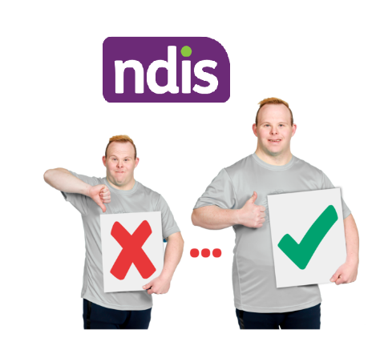 | The NDIS needs to do better to make sure parents with an intellectual disability get the right support.

Getting parenting supports in the NDIS
The NDIS can provide parenting supports to people with an intellectual disability.

For example

- support in the home

- support to do things in the community with their children

- domestic services like cleaning and gardening

- support at appointments and meetings.

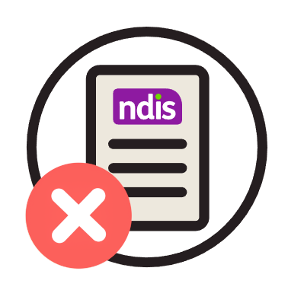 | But many parents with an intellectual disability have trouble getting parenting supports in their NDIS plan.
 | This is because many people do not know the NDIS provides parenting supports so they do not ask.
 | Some parents with an intellectual disability are told by their Support Coordinator or plan manager that NDIS does not provide parenting supports.
 | This means a lot of parents with an intellectual disability are missing out on supports they need.
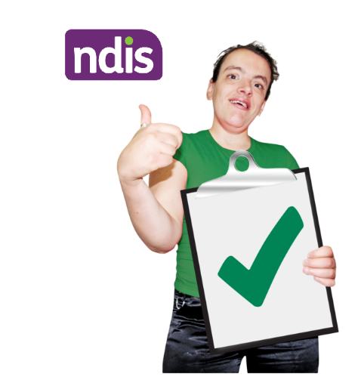 | The NDIS needs to make sure parents with an intellectual disability have access to parenting supports in their NDIS plan.
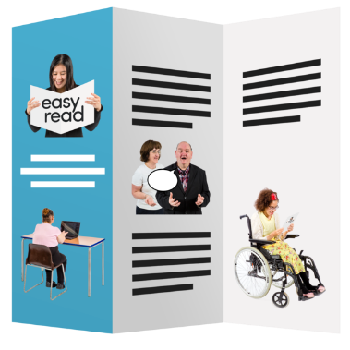 | This means  - making sure plan managers and child protection services know parents with an intellectual disability can get parenting support from the NDIS  - making Easy Read resources about how to get NDIS parenting supports  - checking on service providers regularly to make sure they are giving good parenting support  - giving parents with an intellectual disability funding for peer support.  Peer support is where parents with an intellectual disability can get together to share stories and give each other advice.

Better training on supporting parents with an intellectual disability
Parents with an intellectual disability often get treated poorly by staff who work at the services they need to use.

For example

- NDIS staff

- Plan managers and support coordinators

- Child protection staff

- Family court staff.

A lot of people think parents with an intellectual disability cannot look after their children properly.

People often focus on what the parent cannot do instead of what they can do.

Some parents with an intellectual disability get their children taken away just because of their disability.

The NDIS needs to work with child protection services to make sure parents with an intellectual disability can keep their children.

This means making sure child protection assessments are fair and accessible for parents with an intellectual disability.
The NDIS needs to run human rights training for people who support parents with an intellectual disability.

This means

- NDIS staff

- Support coordinators and plan managers

- Service providers

- Child protection services.

Parents with an intellectual disability should be part of making the training.

Culturally and linguistically diverse and First Nations parents with an intellectual disability
Some parents with an intellectual disability are

- First Nations

- Culturally and linguistically diverse.

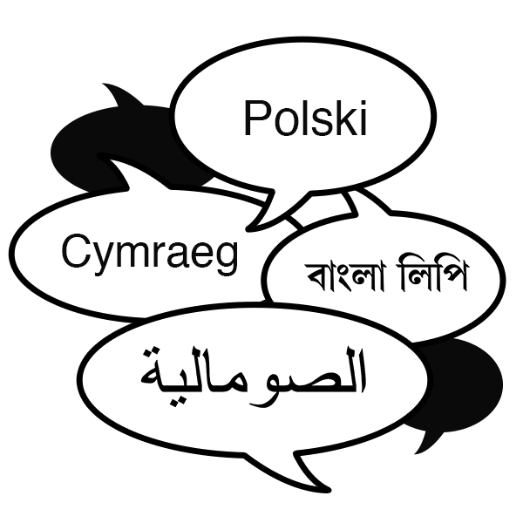 | Culturally and linguistically diverse means you come from another culture, religion or language.
 | Parents with an intellectual disability who are First Nations people or are culturally and linguistically diverse can find it hard to get parenting support.
Services for parents with an intellectual disability who are First Nations or are culturally and linguistically diverse are often

- not easy to find

- not available.

The NDIS needs to make sure there are

- parenting support services with First Nations and culturally and linguistically diverse staff

- parenting resources in other languages.

