Our Submission to the Department of Social Services on Housing and Homelessness

 | This is an Easy Read version of an Inclusion Australia submission.
 | A submission is when we write to the Government and tell them what we think.
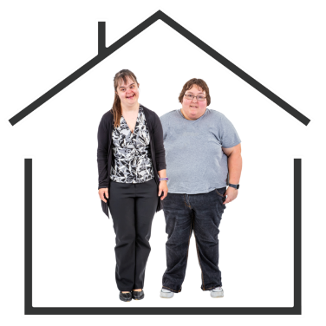 | Our submission told the Government what we think about their National Housing and Homelessness Plan.  We call it the Plan for short.
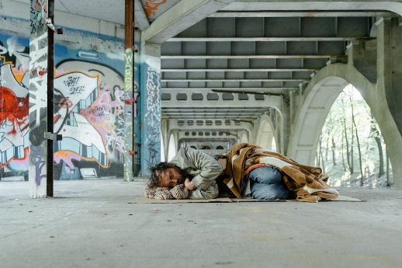 | Homelessness is when people have nowhere to live.
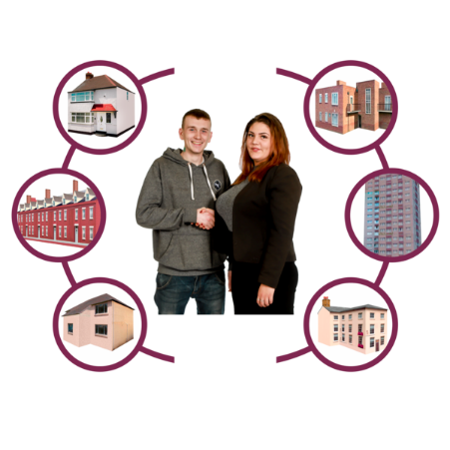 | The Plan will show what the Government will do about housing and homelessness in Australia over the next 10 years.
 | You can find the big version of our submission here.

Housing and homelessness of people with an intellectual disability
People with an intellectual disability in Australia have trouble finding housing that is
- Safe

- Accessible

- Cheap enough.

 | People with an intellectual disability are more likely to have problems with housing and homelessness than most people.
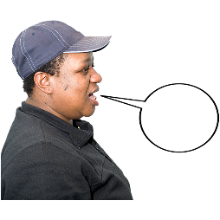  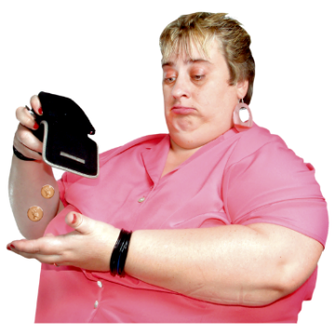 | For example  - Not getting a say in where they live or who they live with  - Being discriminated against when looking for housing  - Having a hard time getting housing supports  - Not being able to afford somewhere to live.
This means lots of people with an intellectual disability must live in places they do not want to.

For example in Supported Independent Living.
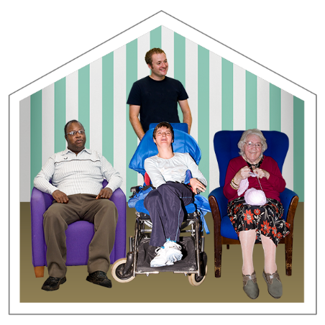 | Supported Independent Living is for people who need a lot of help to live independently.  They are sometimes called group homes.
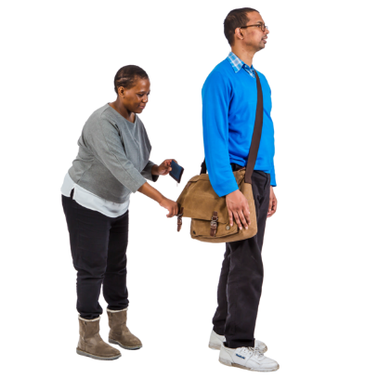 | People with an intellectual disability in a group home are more likely to be  - Hurt  - Neglected  - Taken advantage of.
People with an intellectual disability often get less choice and control over their lives in a group home.

For example what activities they can do and who they can spend time with.

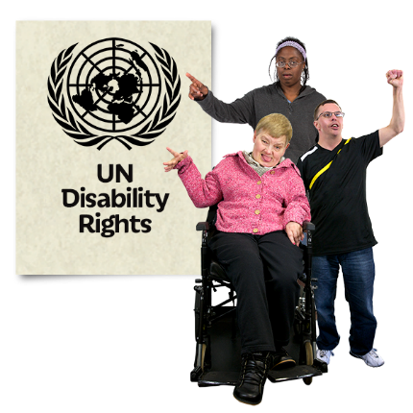 | The United Nations Convention on the Rights of Persons with Disability or UNCRPD for short says people with disability deserve safe and accessible housing just like everyone else.
 | The Disability Royal Commission says people with an intellectual disability need good housing support services.
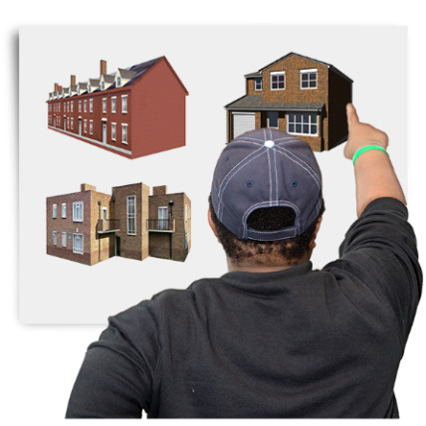 | The Government must make sure the Plan gives more safe and accessible housing options to people with an intellectual disability.
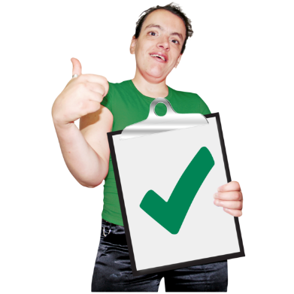 | The Plan must include funding for good housing support services to support people with an intellectual disability.

Supported decision making
 | People with an intellectual disability have the right to choose where they live and who they live with.
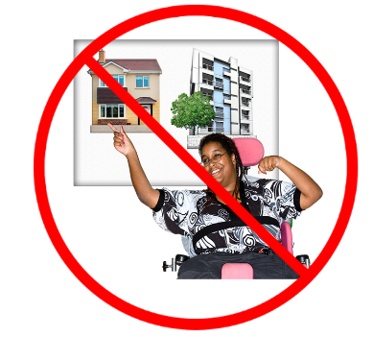 | But this does not happen very often.
 | People with an intellectual disability are often forced into group homes or other living situations they are not happy with.
 | The UNCRPD says that people with disability should be able to make their own decisions about where they live and who they live with.
 | This includes good support when making decisions about housing.
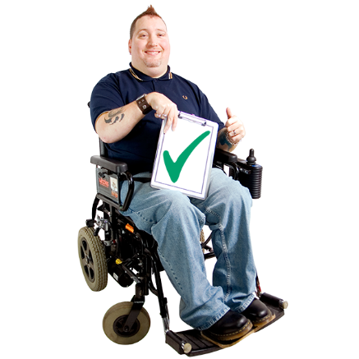 | The Plan must include funding for supporting decisions about housing for people with an intellectual disability.
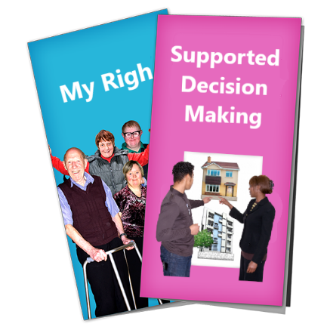 | The Government must make sure there are accessible resources about supported decision making.
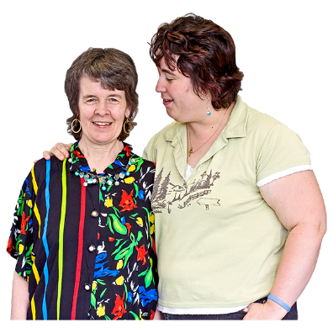 | These resources should be available for people with an intellectual disability and their supporters.

Cost of living
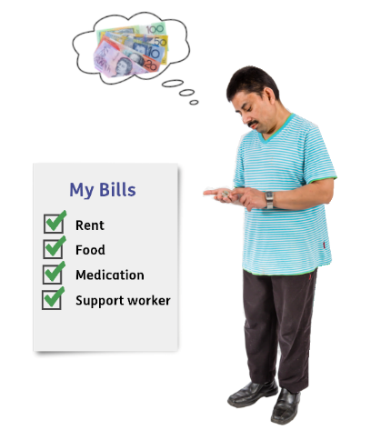 | Many people with an intellectual disability live below the poverty line.  This means they are more likely to have trouble affording everyday things like rent and groceries.
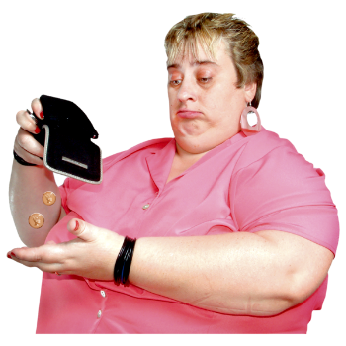 | People with an intellectual disability often have expenses that others do not.  For example  - Medications  - Doctors and specialist appointments.
 | 7 out of 10 people with an intellectual disability rely on the Disability Support Pension to get by.
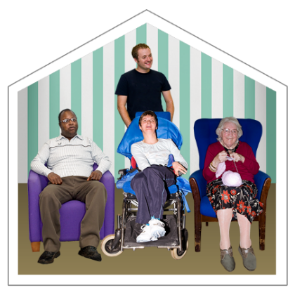  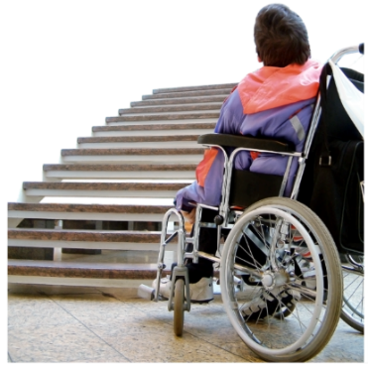 | This means lots of people with an intellectual disability must live in places they do not want to because it is cheaper.  For example  - In group homes  - In housing that is unsafe  - In housing that is not accessible  - In housing that is far away from supports.
This can make people with an intellectual disability feel

- Sad or depressed

- Unheard.

People are also more likely to be treated badly or hurt in these places.

 | The Plan must include more safe and affordable housing options for people with an intellectual disability.

What happens next?
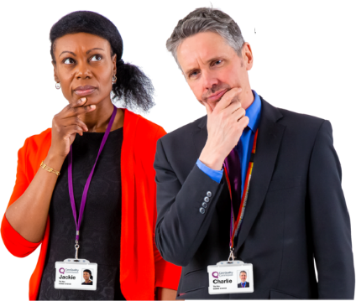 | The Government will look at what we said and think about how to make the Plan work for everyone.
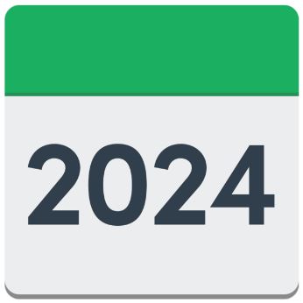 | The final version of the Plan will be released sometime in 2024.

