A message about the NDIS Review

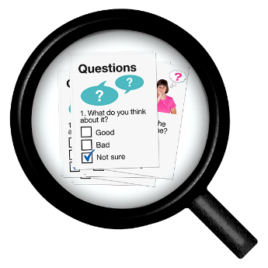 | The Australian Government has done a Review of the NDIS.  They want to make sure the NDIS is working.
 | This is a message is about the NDIS Review.
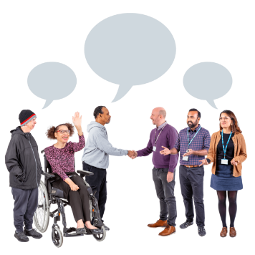 | Lots of different disability groups wrote this message together.
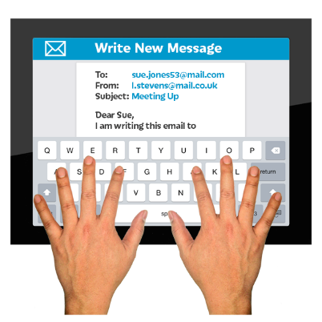 | We will send this message to people that work in TV news, radio and in newspapers.
 | They might make a news story using our message.

Our message

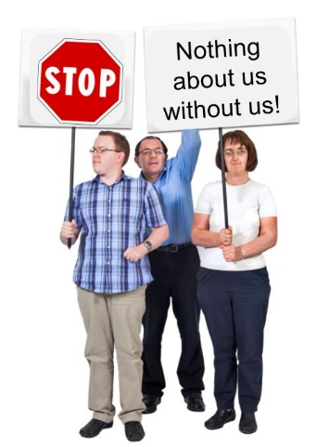 | We think any change to the NDIS must be led by people with disability.
People with disability, families and carers talked with people who wrote the Review.

Many people shared their stories.
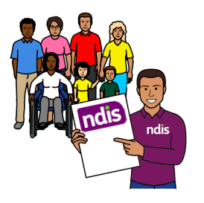 | People with disability said the NDIS is very important. It helps people to go to school, work and the community.  The NDIS helps people with disability to build skills and be more independent.
People with disability said that the NDIS is good but can be hard to use.

It can also be hard to find supports.
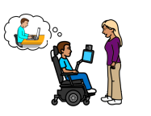 | We want to make sure every person with a disability has the support they need.  The support could be from the NDIS, schools or other community groups.
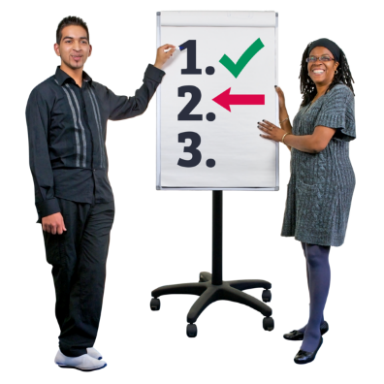 | We want people with disability to be a part what happens next after the NDIS Review.
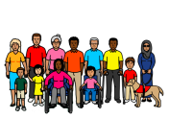 | We think there should be a new group.  This group would work with the government to make the NDIS better for everyone.
 | We want this group to be called the Disability Reform Implementation Council.
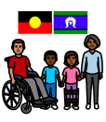 | First Nations people with disability must be included in the plan and given supports they need.
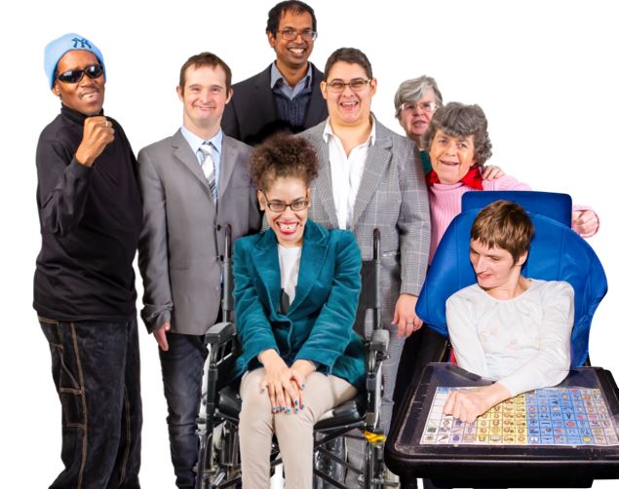 | We want all governments to make sure people with disability are included.  Nothing about us without us.

This message was made by:

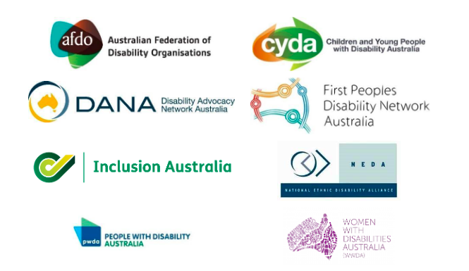

This message has been supported by lots of disability groups in Australia.
If you have any questions about this message, please email us:

- Jane jane@upstride.com.au
- Janelle janelle@upstride.com.au

